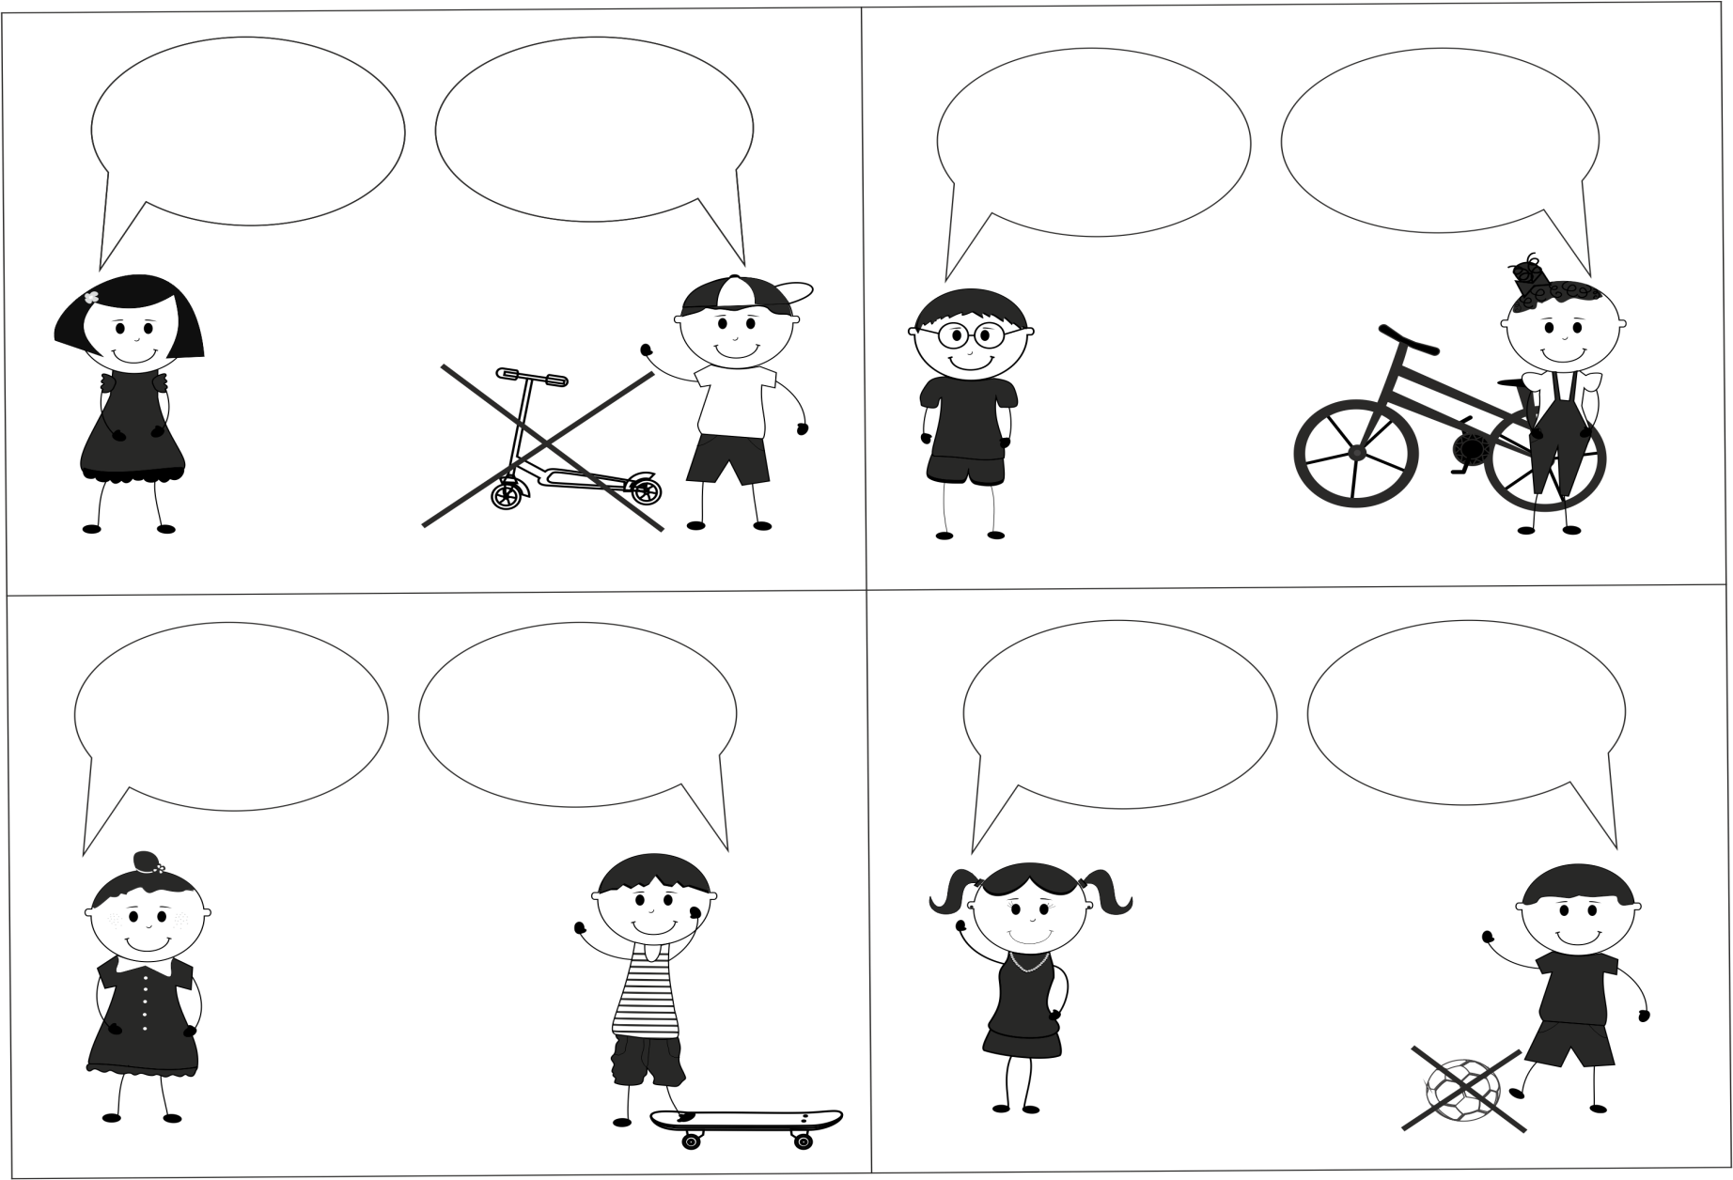
Have you got a bike?
Yes, I have.
… you got a
skateboard?
Yes, I have.
Have you got a …?
No, I haven’t.

