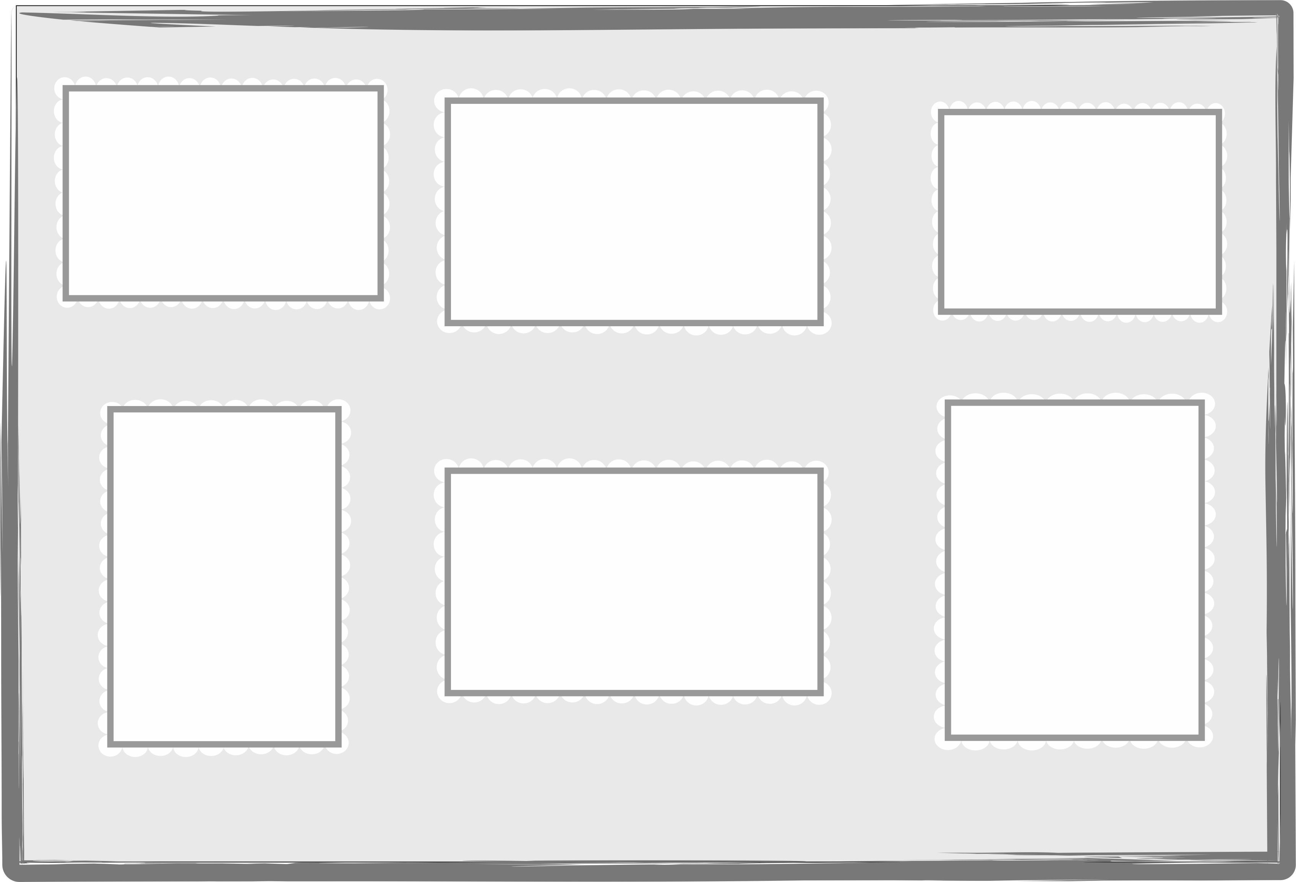
This is my ............................... .
My .................. is .................... .

This is my ............................ .
My .......... ....... is ................ .
This is my ............................ .
My .......... ....... is ................ .
This is my ............................ .
My .................. is ................ .
This is my ............................ .
My .......... ....... is ................ .
This is my ............................ .
My .......... ....... is ................ .

