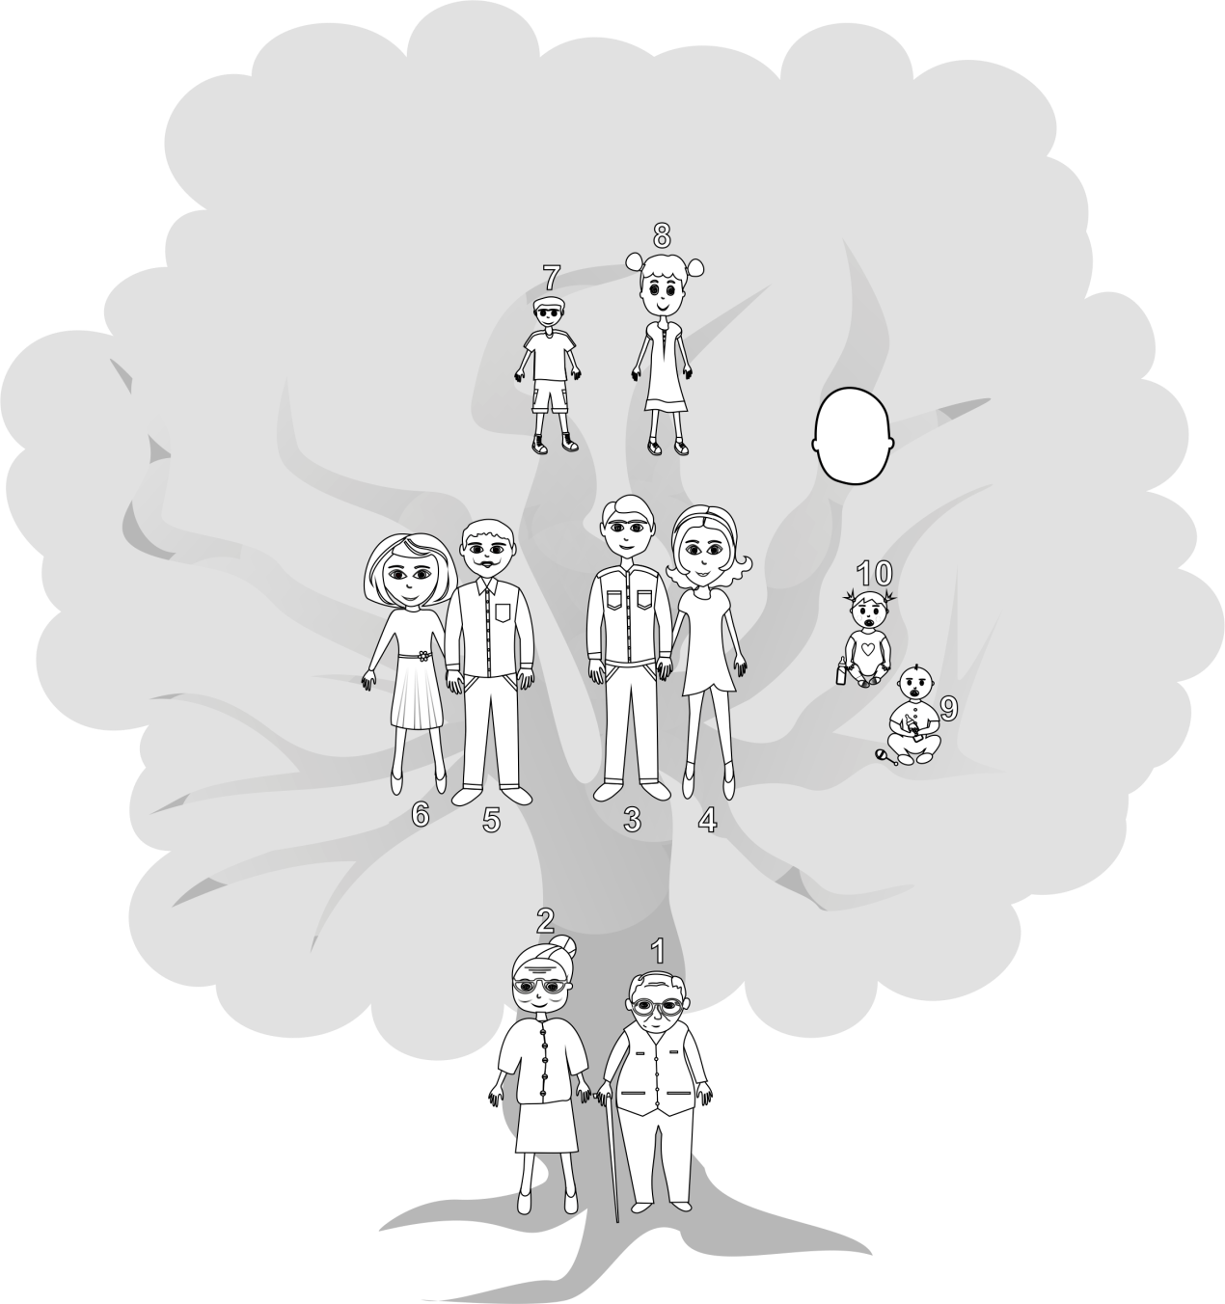
My mum is short/tall.

My auntie is nice/tall.
My uncle is pretty/funny.
My granddad is
pretty/short.

My brother is funny/tall.

My babysister is pretty/short.
Me
- This is my ............................... . My .................. is .................... .
- This is my ............................... . My .................. is .................... .
- This is my ............................... . My .................. is .................... .
- This is my ............................... . My .................. is .................... .
- This is my ............................... . My .................. is .................... .
- This is my ............................... . My .................. is .................... .
- This is my ............................... . My .................. is .................... .
- This is my ............................... . My .................. is .................... .
- This is my ............................... . My .................. is .................... .
- This is my ............................... . My .................. is .................... .

