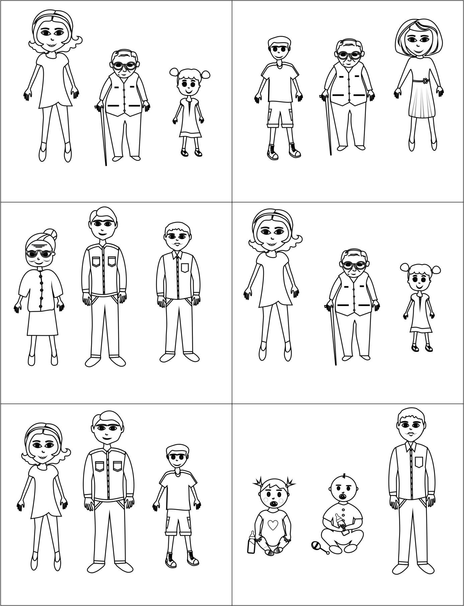
My mum is short/tall.

My auntie is nice/tall.
My uncle is pretty/funny.
My granddad is
pretty/short.

My brother is funny/tall.

My babysister is pretty/short.
My grandad is short.

My brother is nice.
My sister is pretty.

My grandma is funny.

My dad is tall.

My baby brother is funny.

