HOUSE
- Pokoloruj pola, na których znajdują się nazwy związane z domem. Odczytaj hasło.
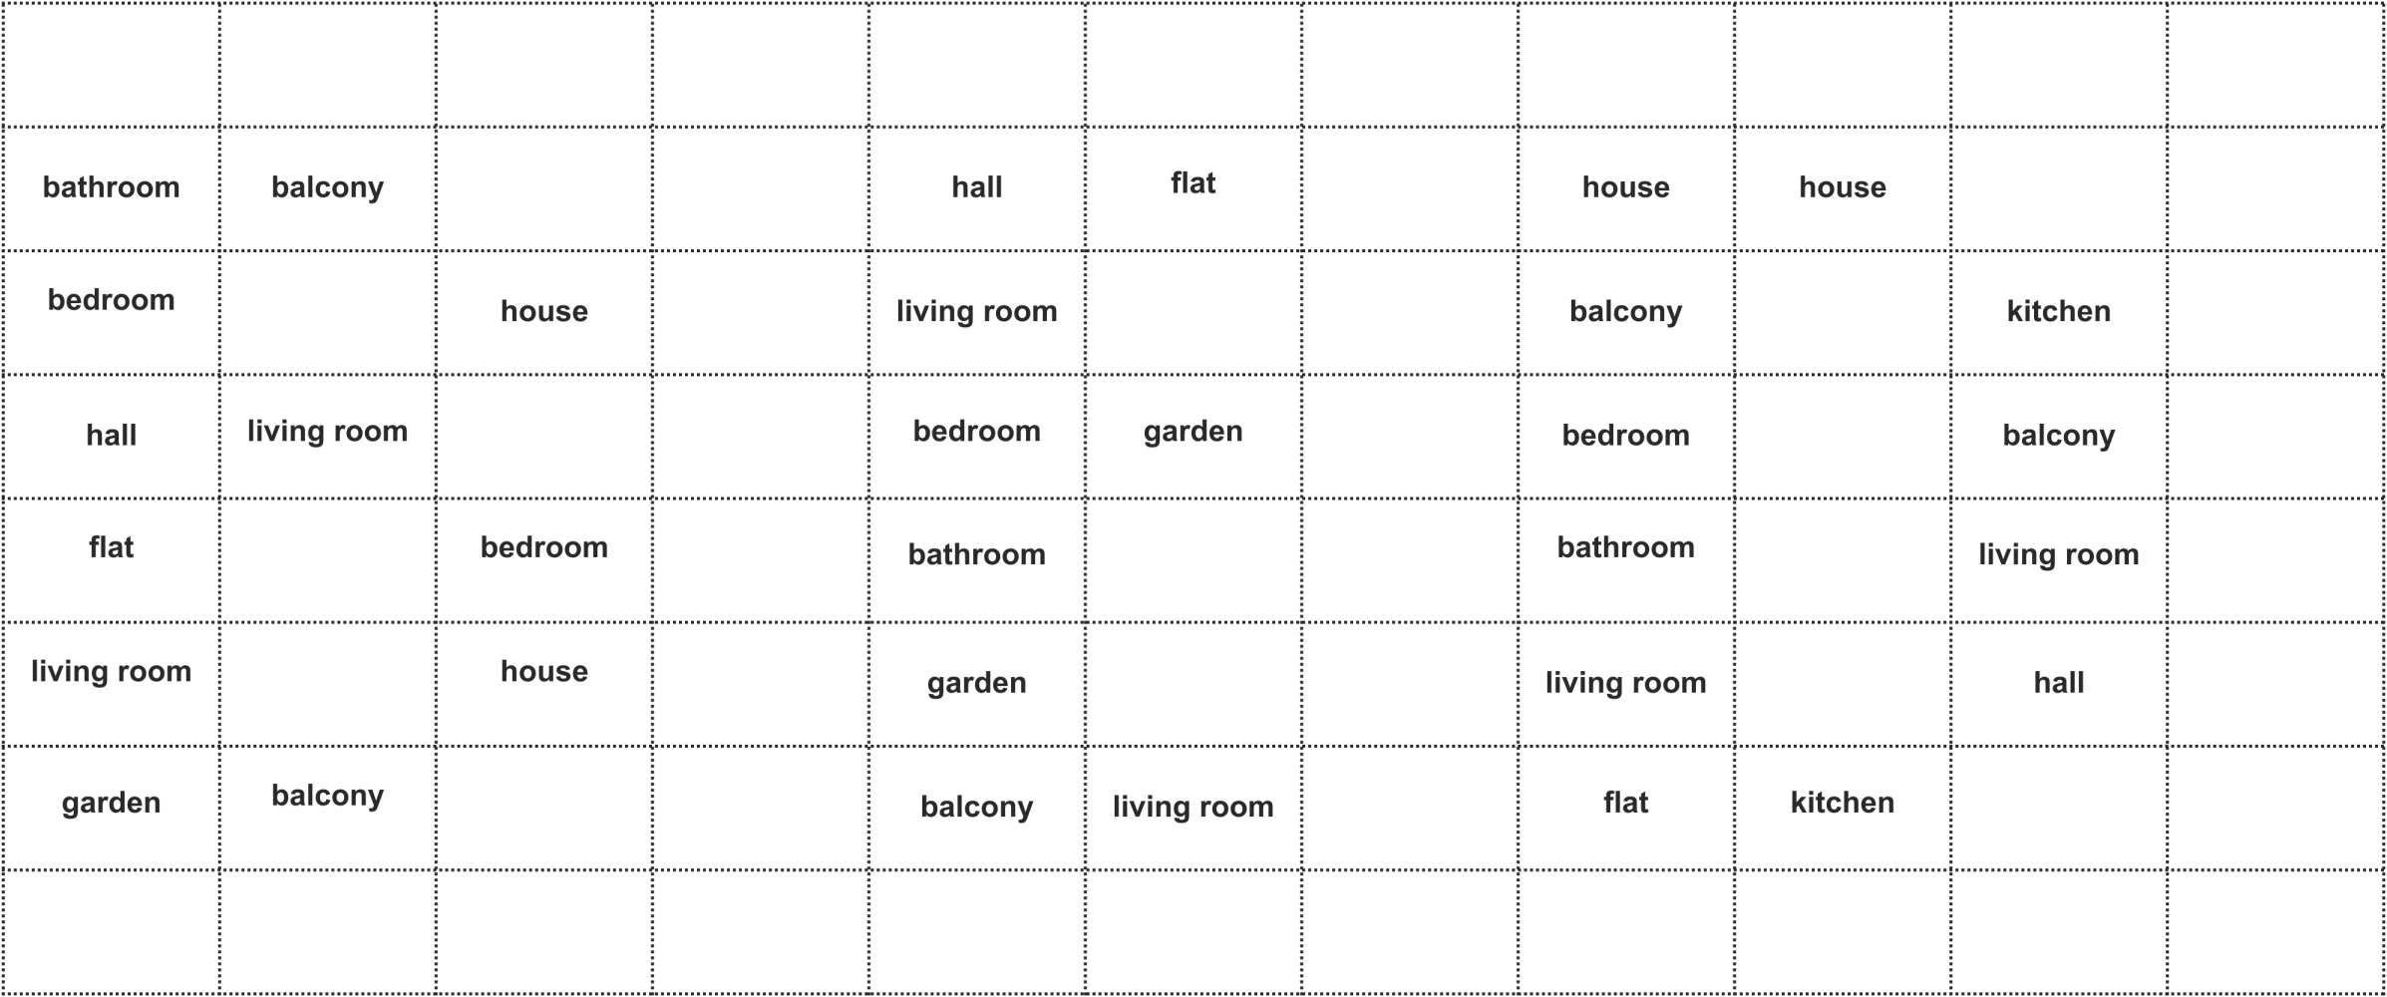
red
bathroom
bedroom
hall
flat
living room
garden
pencil
book
balcony
draw
living room
point
balcony
look
yellow
grey
repeat
house
wait
bedroom
house
three
rubber
five
cheat
tomato
blue
touch
eight
orange
help
five
pink
hall
living room
bedroom
bathroom
garden
balcony
potato
leg
flat
green
garden
ready
four
please
living room
one
seven
eyes
black
nine
pen
listen
ears
notebook
house
balcony
bedroom
bathroom
living room
flat
point
draw
house
repeat
red
yellow
grey
kitchen
orange
potato
apple
kitchen
balcony
living room
hall
green
two
three
six
leg
pink
cat
bike
cheat
doll

