Wpisz:  Sausage  Roll  Sandwich  Bread  Pizza | 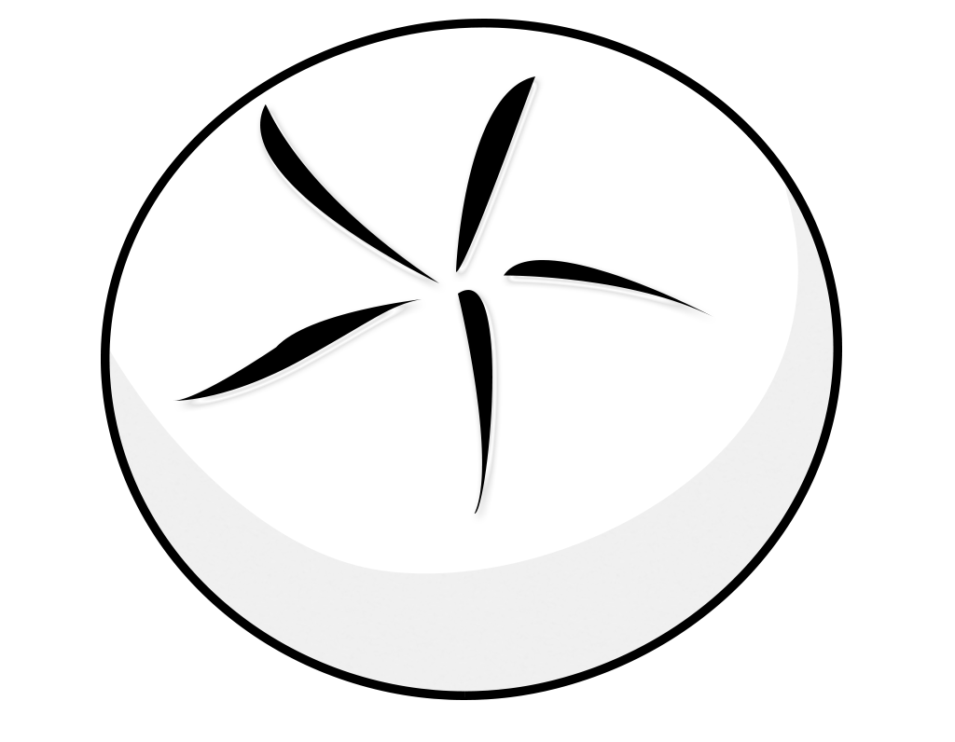  R _ _ _
  S _ _ _ _ _ _ | 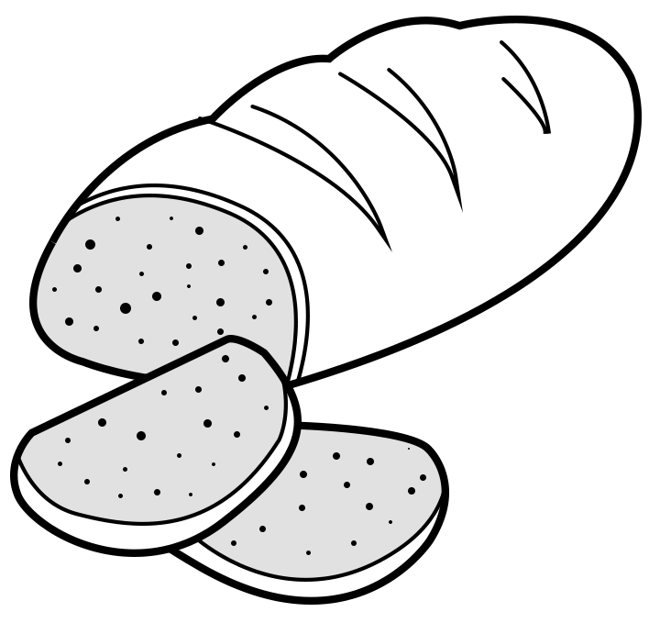  B _ _ _ _
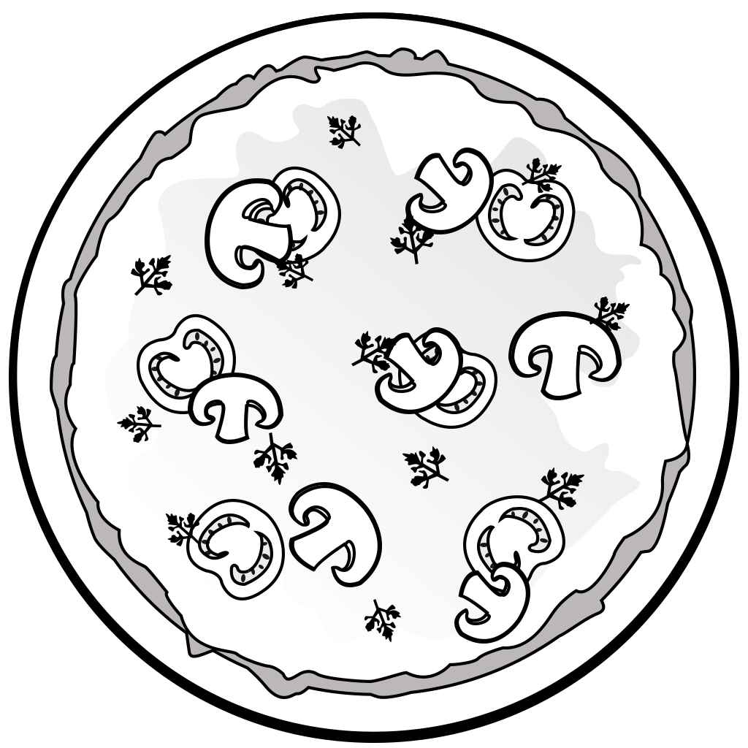  P _ _ _ _ | 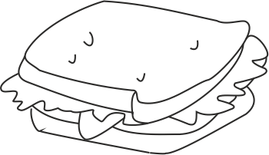  S _ _ _ _ _ _ _

Wpisz:  Ice cream  Pasta  Chicken  Tea  Apple | 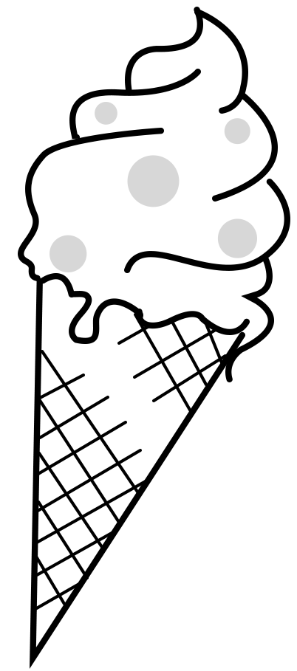  I _ _ C_ _ _ _
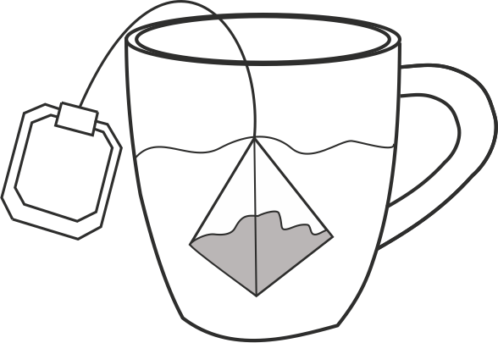  T _ _ | 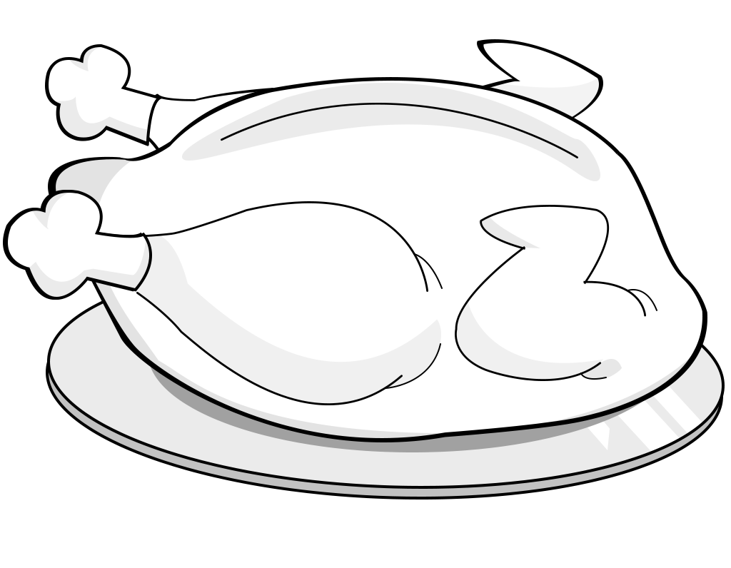  C_ _ _ _ _ _
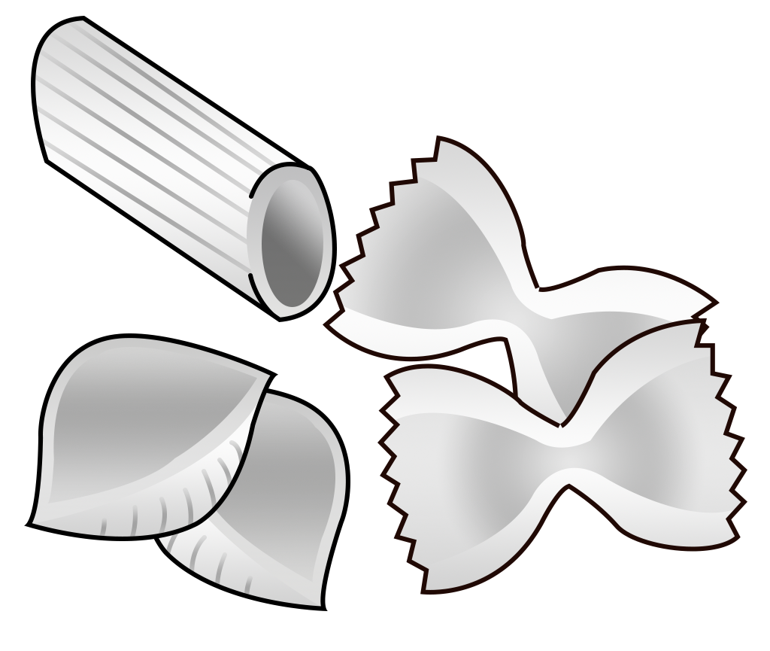  P _ _ _ _ |   A _ _ _ _

Wpisz:  Jelly  Banana  Chips  Juice  Cornflakes | 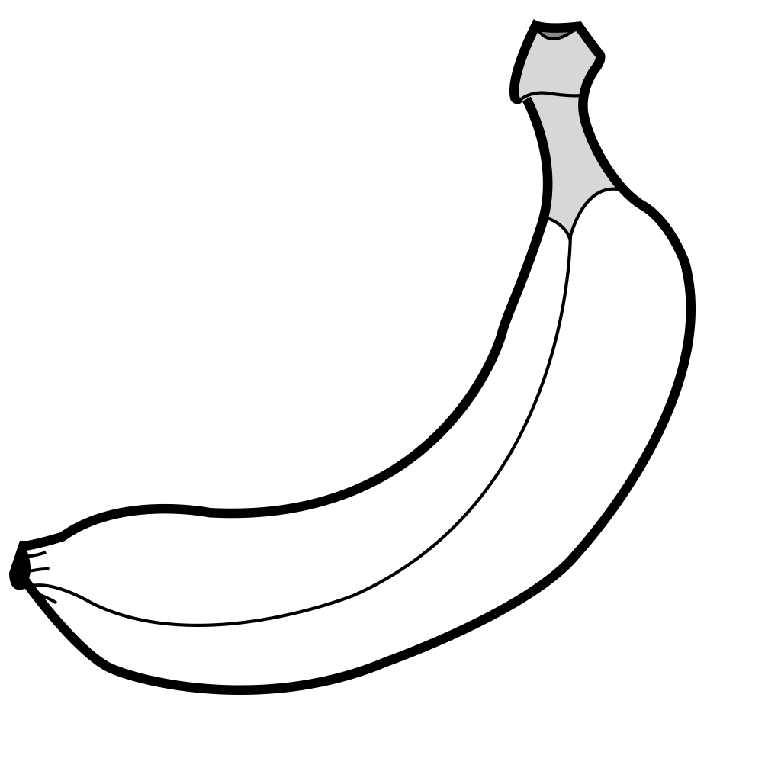  B _ _ _ _ _
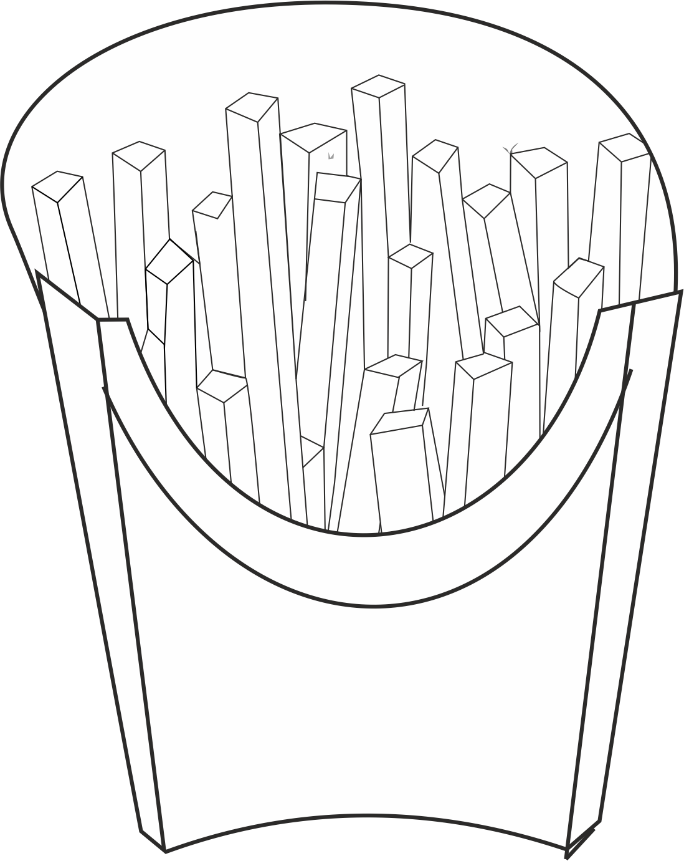  C _ _ _ _ | 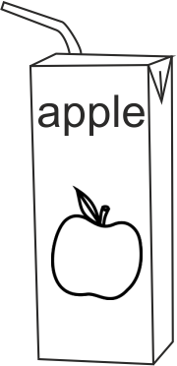  J _ _ _ _
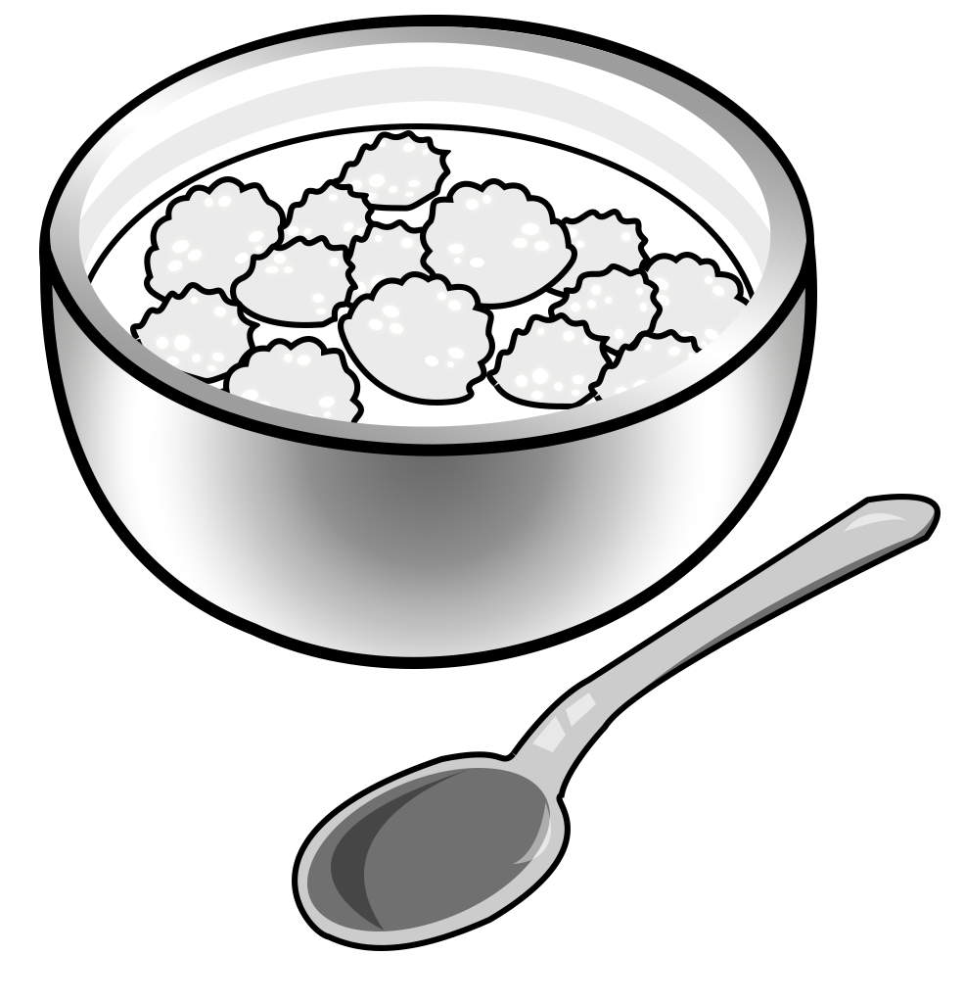  C _ _ _ _ _ _ _ _ _ | 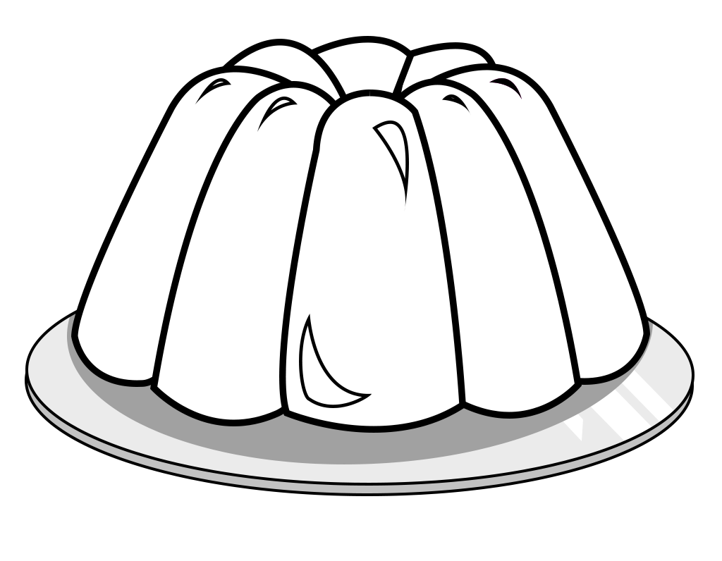  J _ _ _ _
Wpisz:  Crisps  Muffin  Milk  Tangerine  Cheese |   M _ _ _
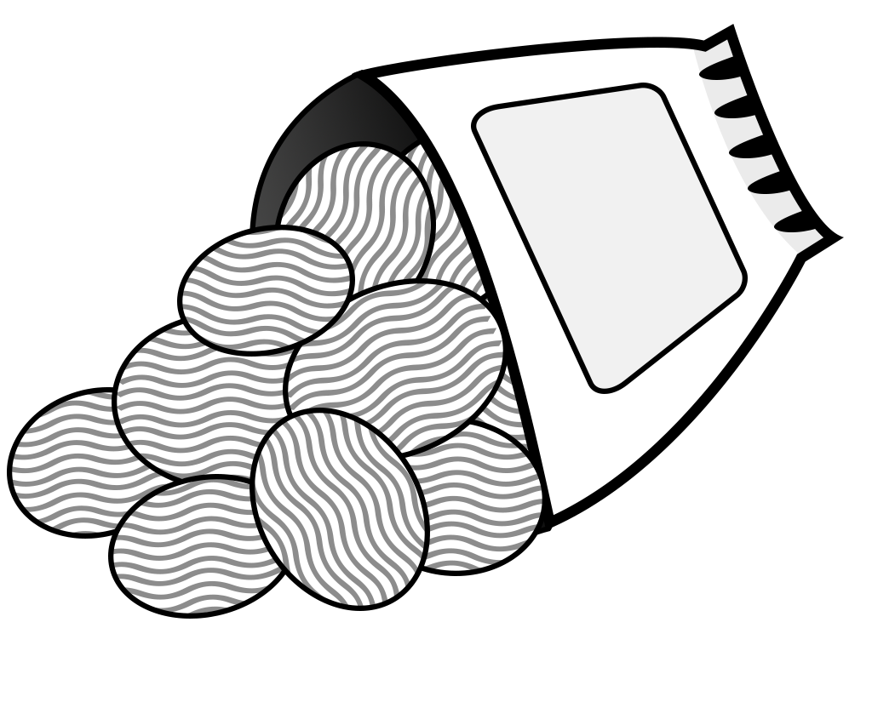  C _ _ _ _ _ |   M _ _ _ _ _
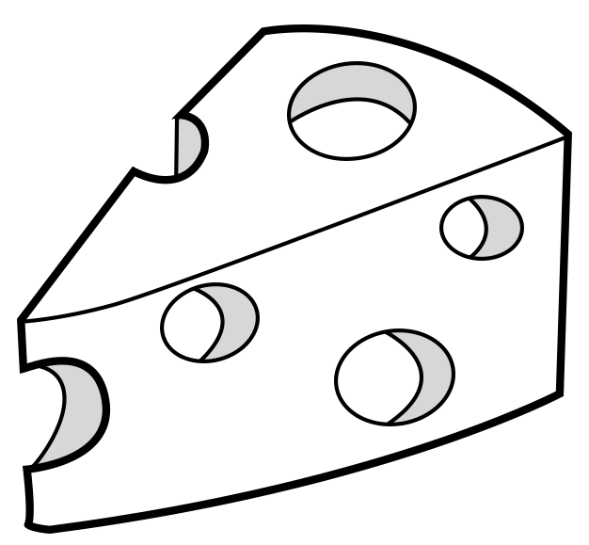  C _ _ _ _ _ | 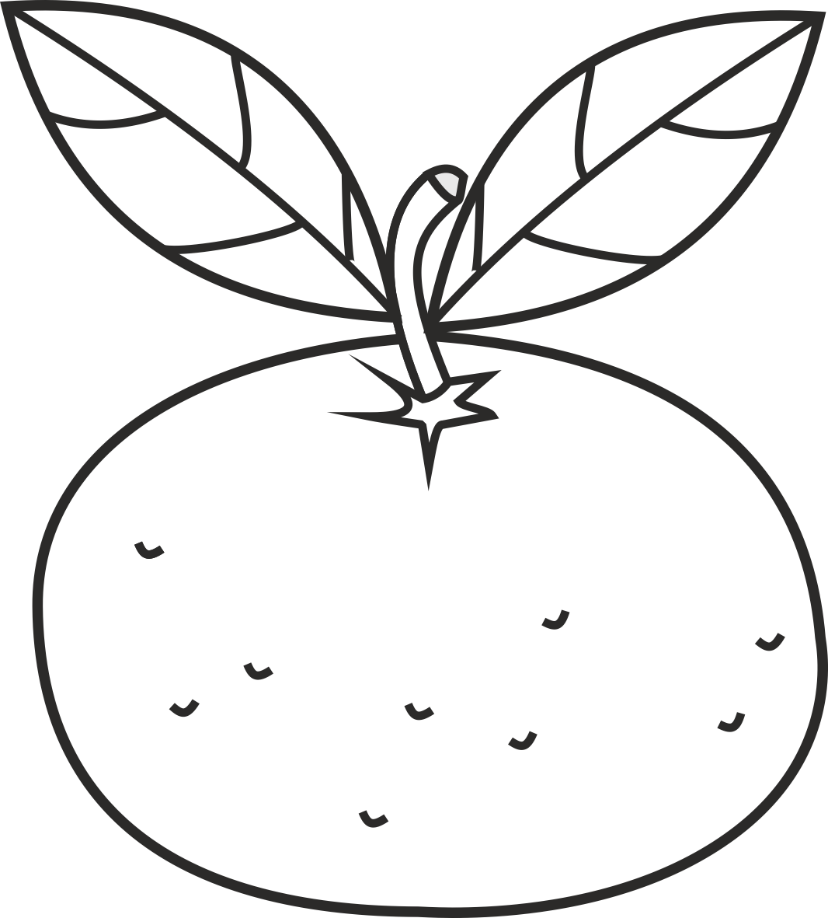  T _ _ _ _ _ _ _ _

