Pokoloruj gałki lodów zgodnie z opisem.
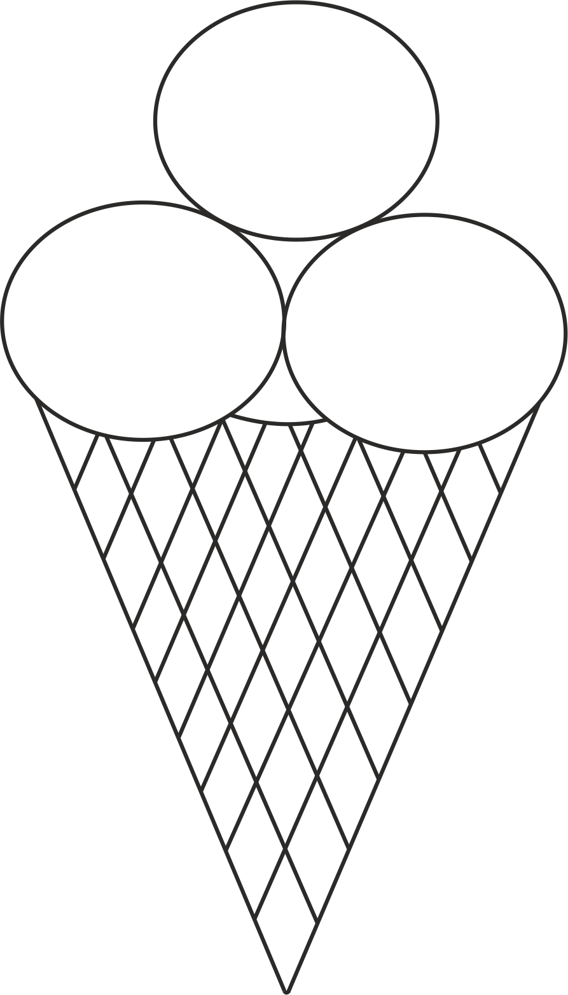
I have 2 strawberry scoops and 1 vanilla scoop. | I have 1 vanilla scoop and 2 chocolate scoops. | I have 1 chocolate scoop and 2 strawberry scoops.

