PART A - Say what the children are doing.
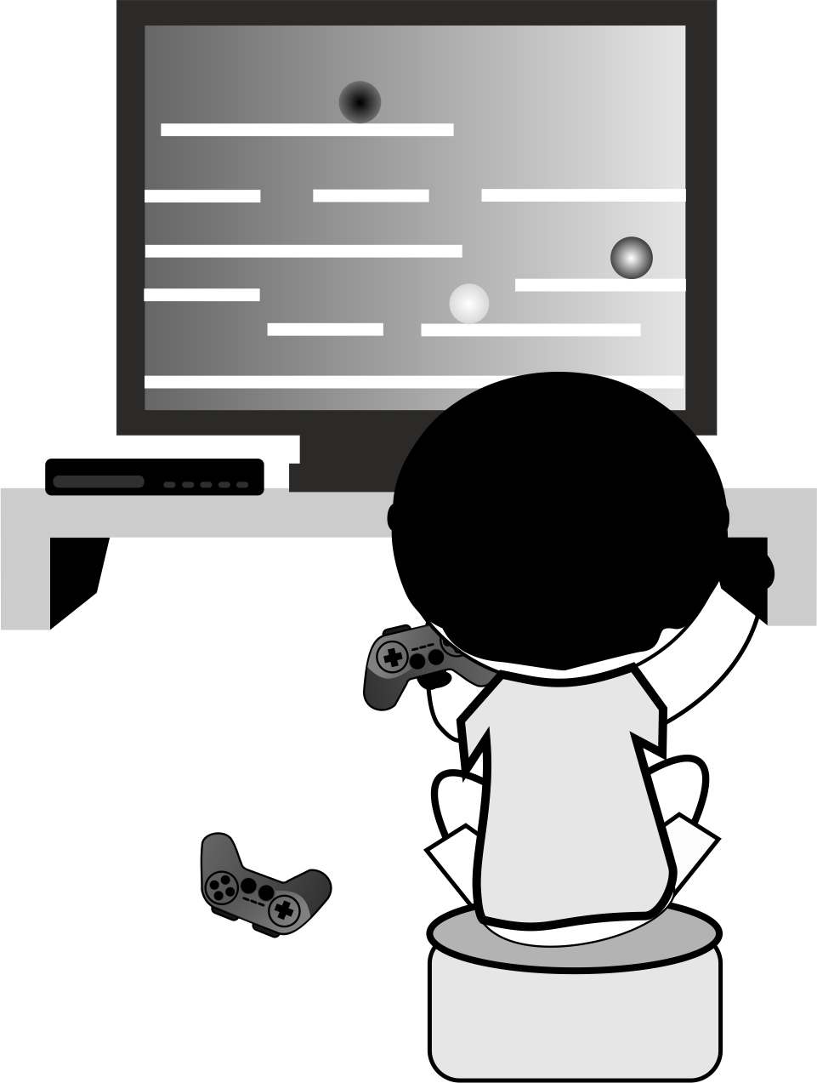 | 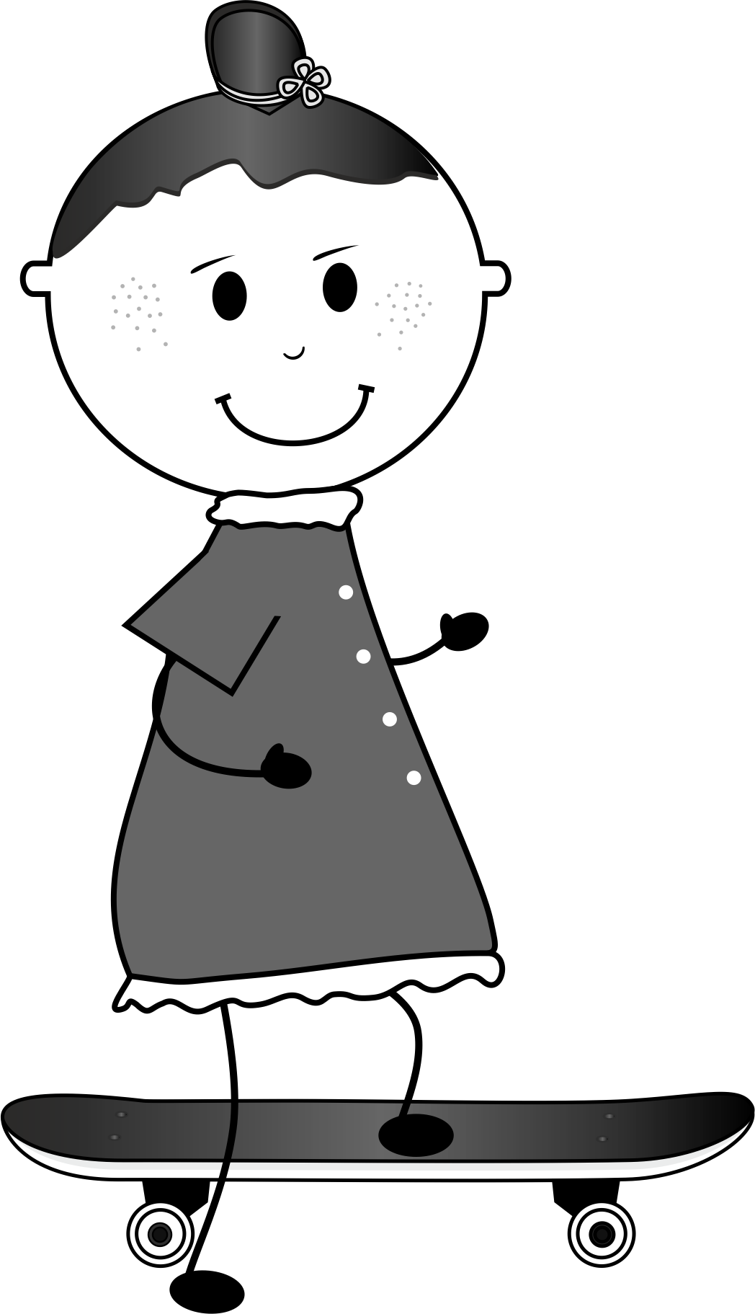 | 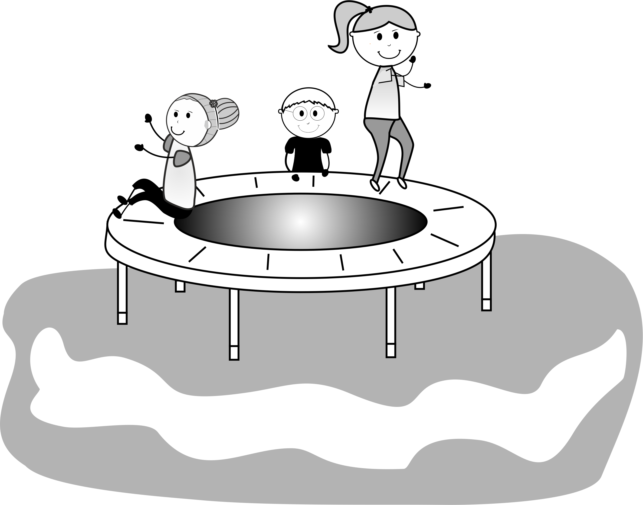
Rob | Kelly | Aron, Rita and Dora
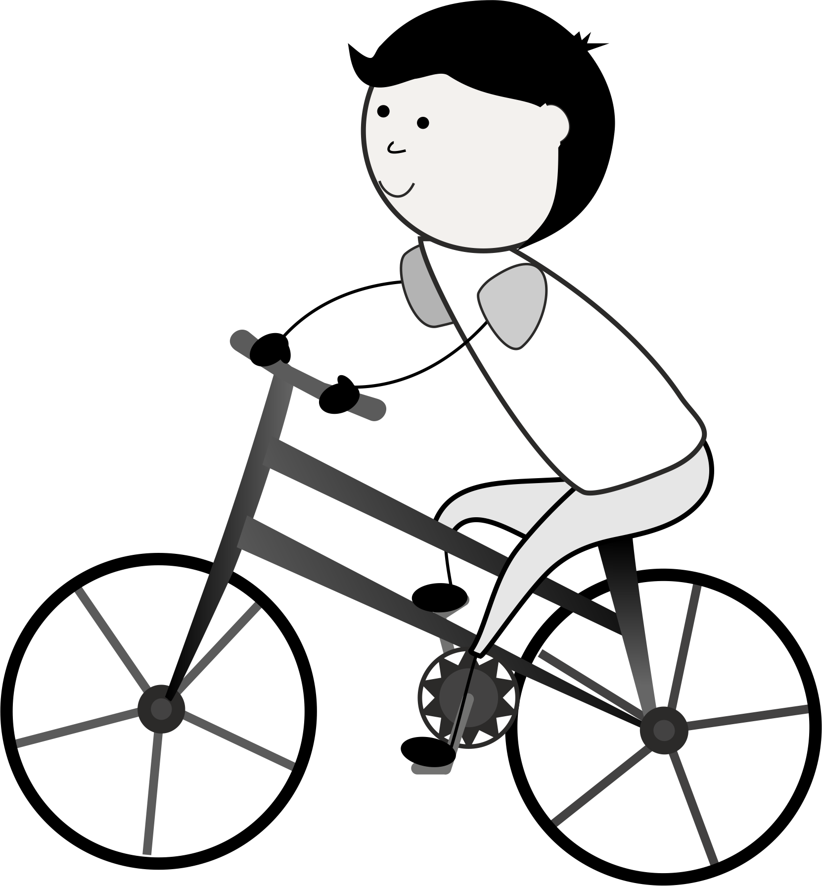 | 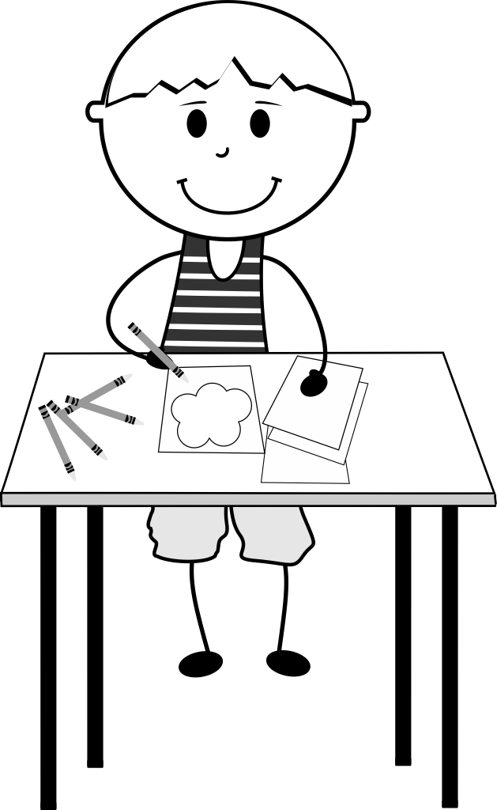 | 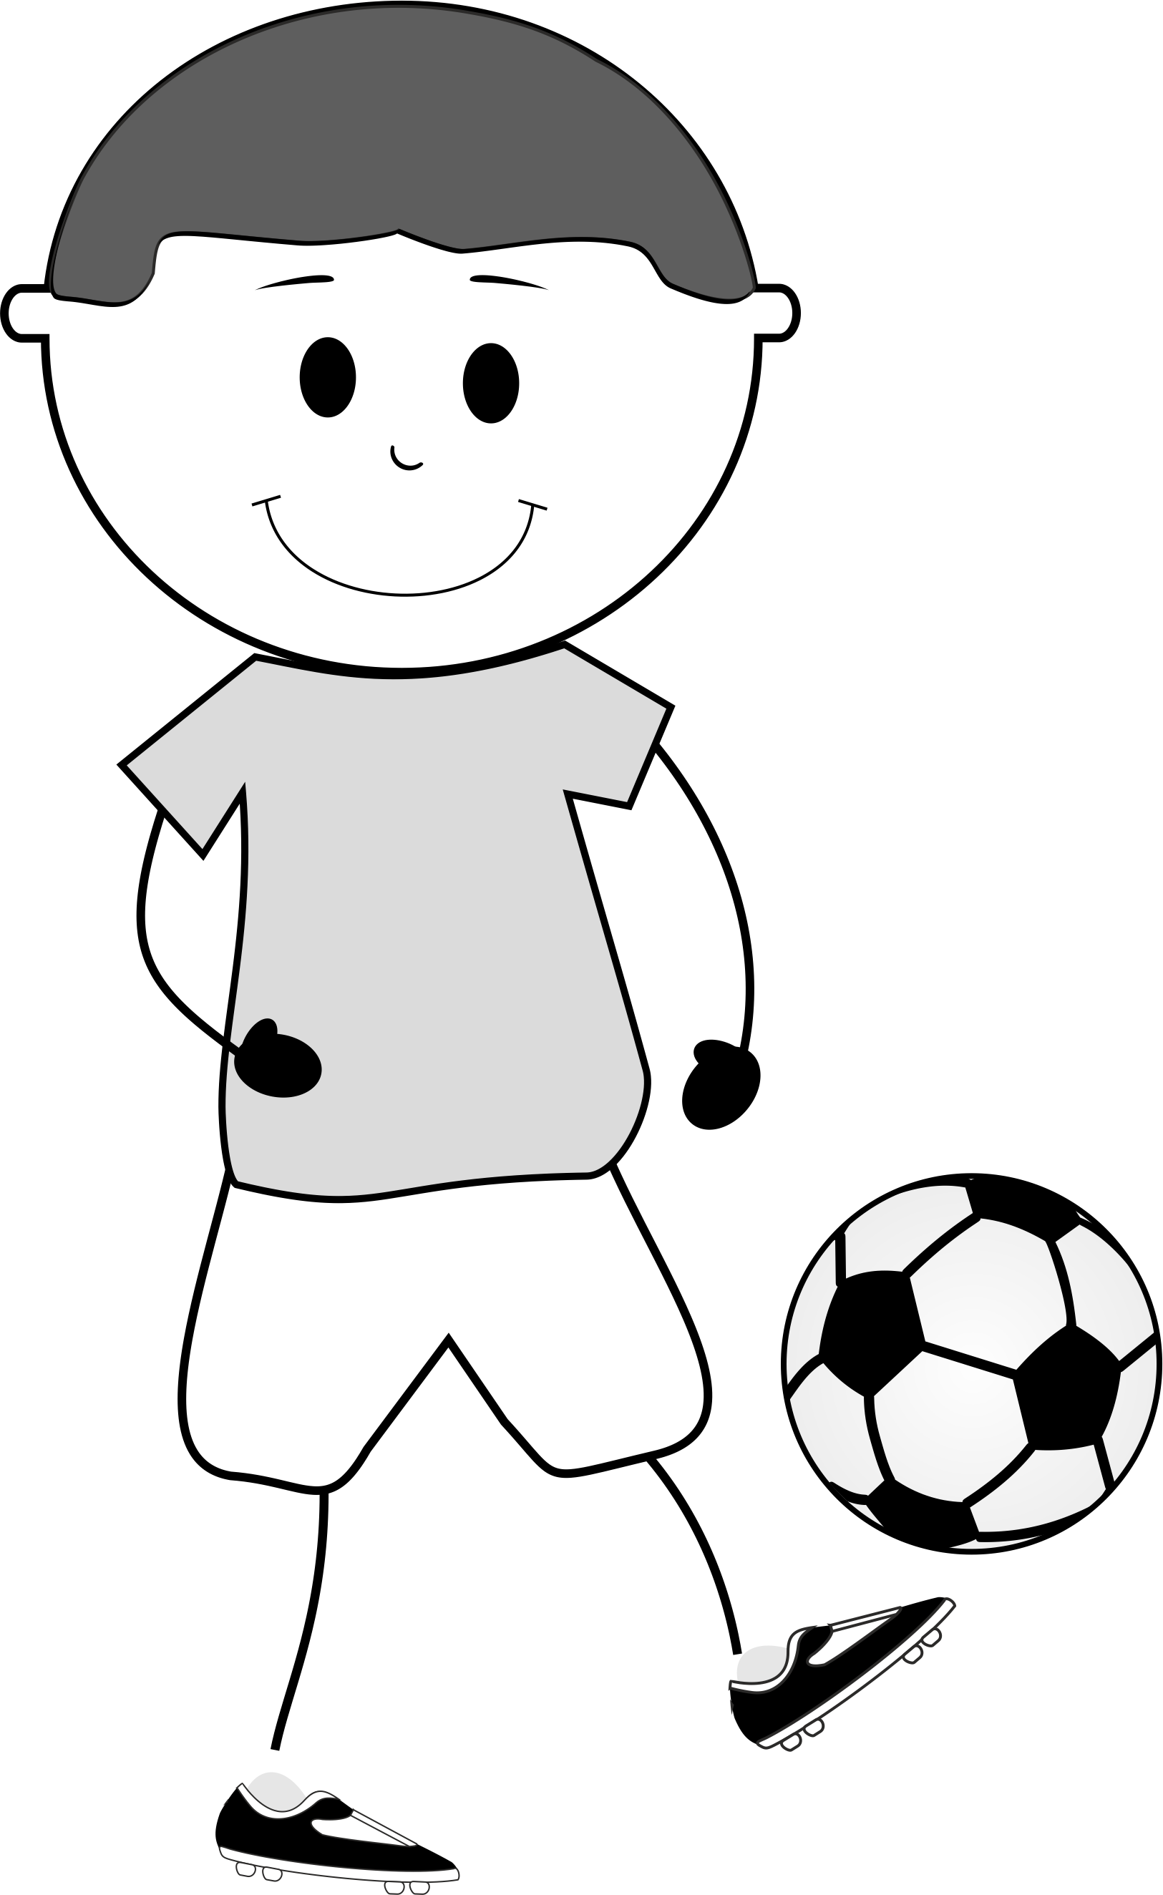
Tom | Jimmy | Peter

PART B - Listen to your friend. Write the names.
.................................. | .................................. | ..................................
................................... | ................................... | ...................................

