PART A - Say what the children are doing.

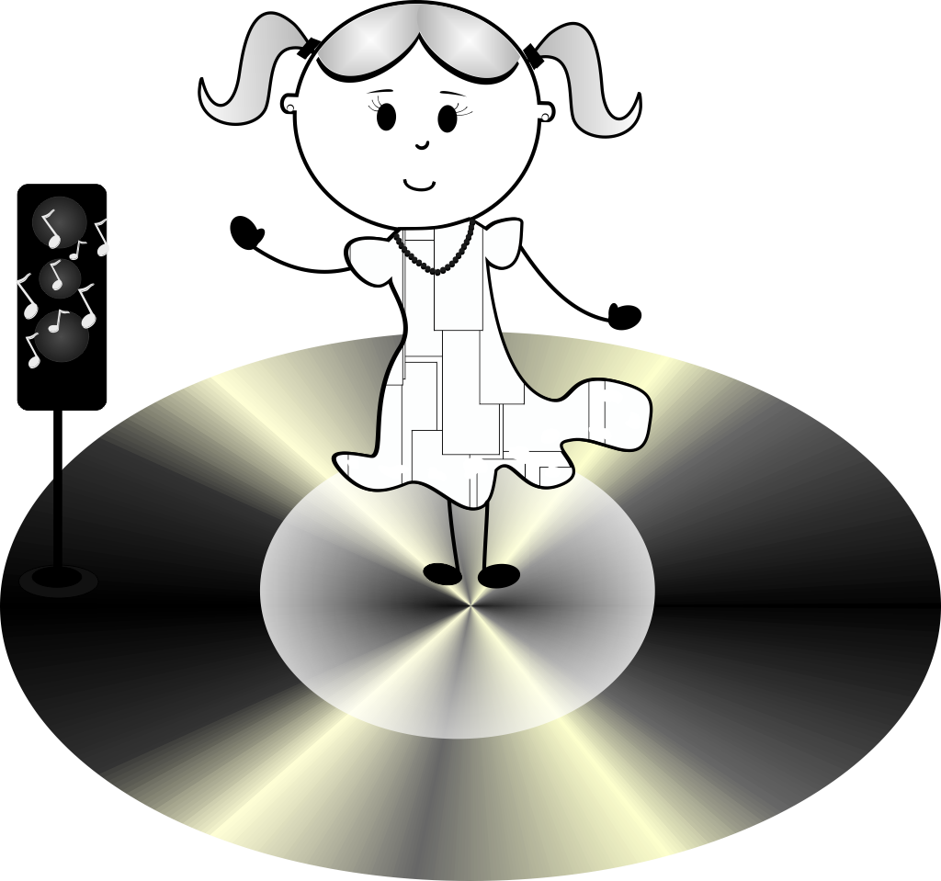 | 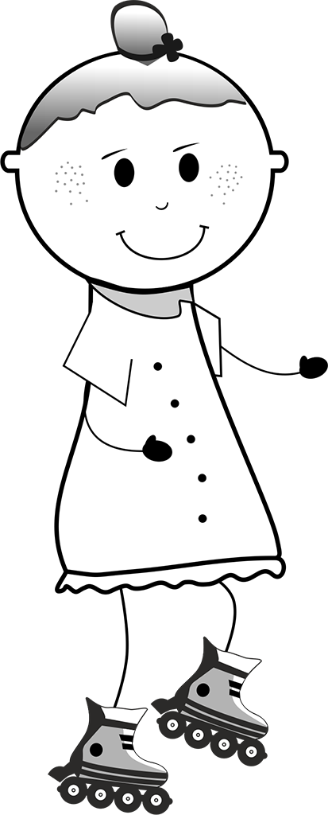 | 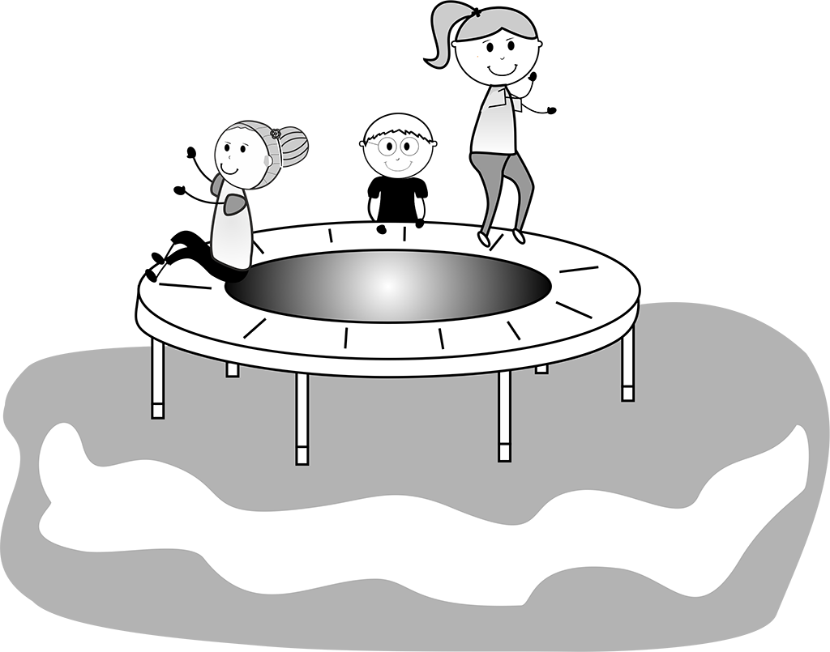
Annie | Emma | Lizzy, Jon and Betty
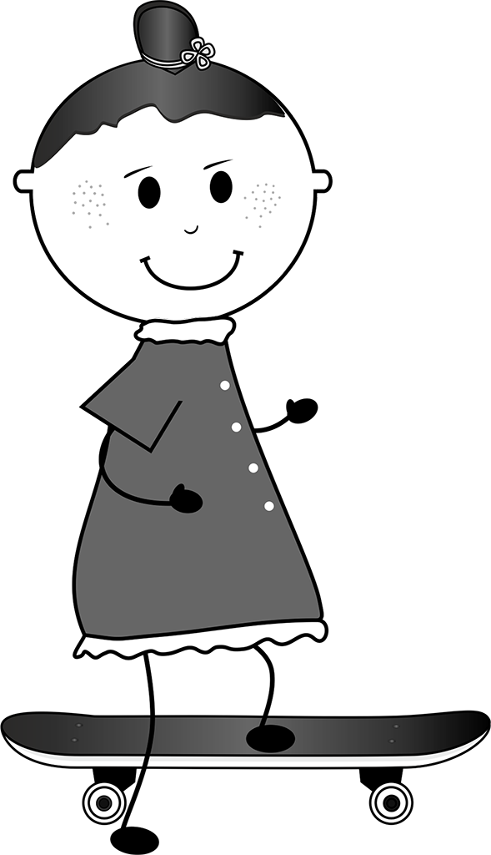 | 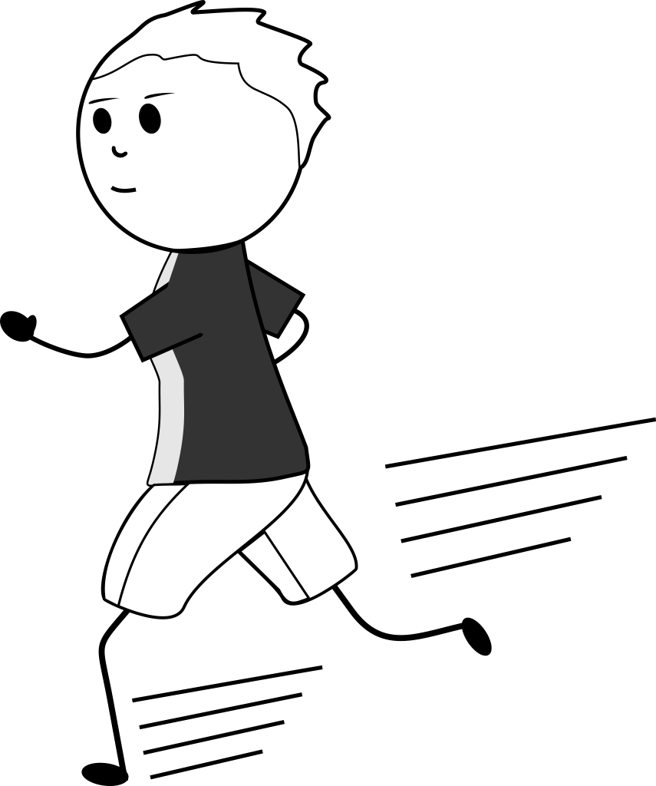 | 
Jessica | Robbie | Chris

PART B - Listen to your friend. Write the name.

............................................ | ............................................ | ............................................
............................................ | ............................................ | ............................................

