- Learn the good manners rap.

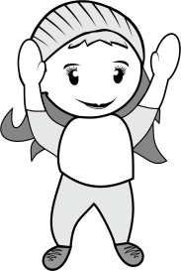
I can say “Thank you”
I can say “Cheers”
I can say “Please”
I know “Excuse me”
I know “You’re welcome”
And “Here you are” when I’m at the table
“Have a nice weekend”
“Have a nice day”
So please remember
don’t be rude
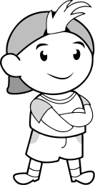
cause only nice kids
will rule:)

Today I pledge to be kind,
to use the nicest words I can find.
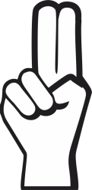

sign here your fingerprint here

