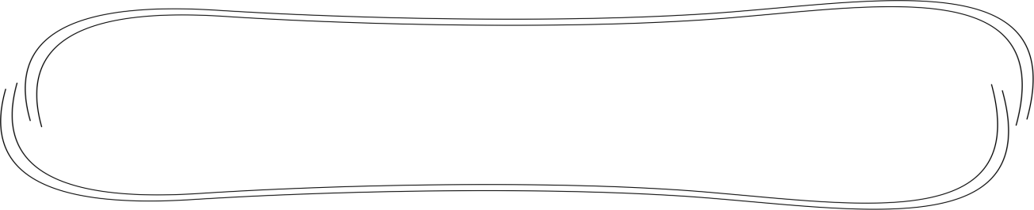
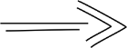
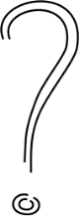
Find the words in the grid.

twenty, thirty, forty, fifty, sixty, seventy, eighty, ninety, one hundred
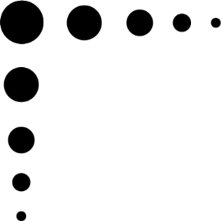
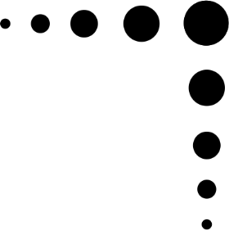
g | m | d | q | d | p | o | u | d | c | s | s
o | n | e |  | h | u | n | d | r | e | d | l
v | y | e | n | e | s | g | d | m | j | f | t
c | r | i | p | i | x | i | v | e | n | b | q
q | s | g | u | t | g | h | x | o | j | j | s
h | c | h | v | w | d | a | j | t | h | g | e
m | f | t | u | e | q | n | s | n | y | s | v
j | i | y | d | n | a | g | i | y | f | t | e
a | f | v | k | t | t | q | q | n | a | e | n
a | t | k | m | y | d | f | p | d | e | o | t
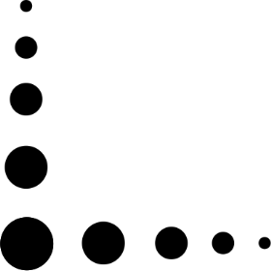  x | y | k | b | r | a | t | f | t | d | 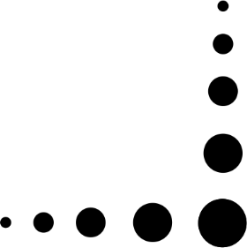  t | y
f | o | r | t | y | t | h | i | r | t | y | y

