- Find the answers to the questions in the word snakes.

- How old is your mum?


- How old is your dad?


- How old is your sister?


- How old is your brother?


- How old is your grandmum?
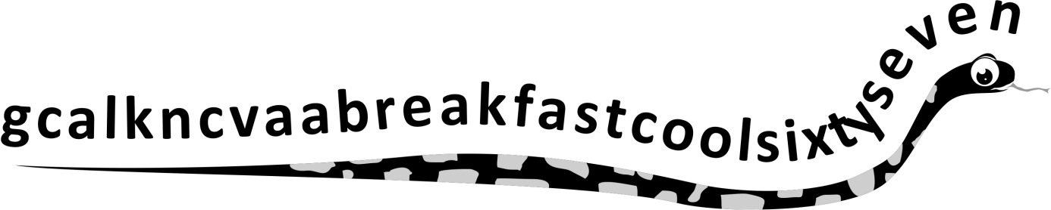

- How old is your granddad?


