- Talk to your friend and fill in information. How much is...? It’s…
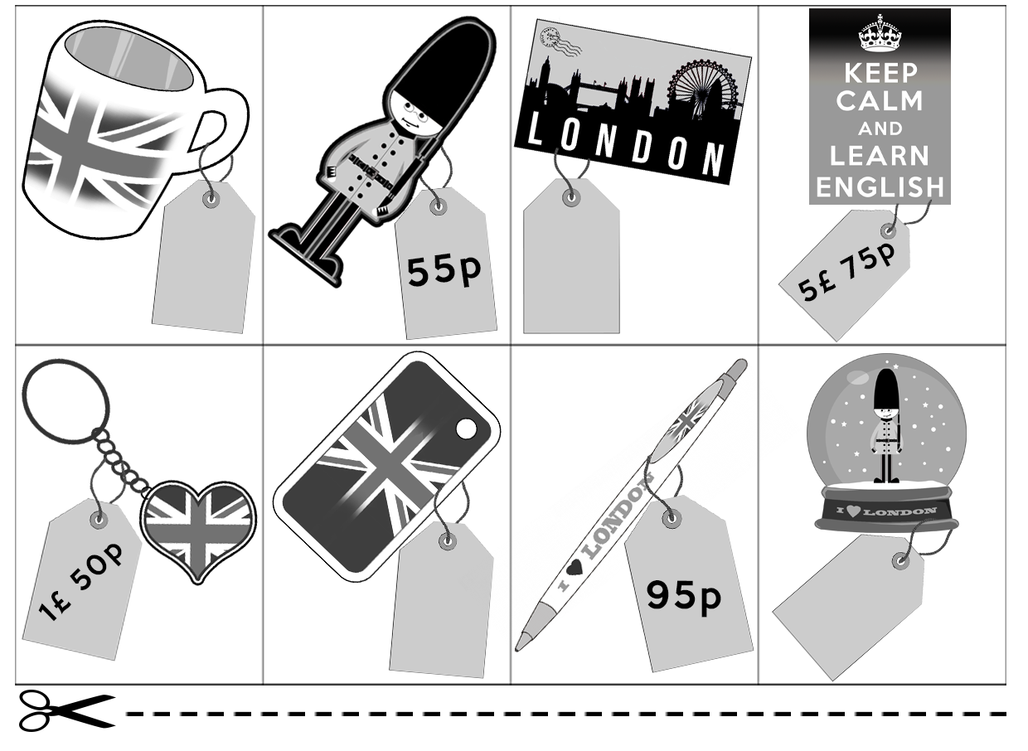
- Talk to your friend and fill in information. How much is...? It’s…
