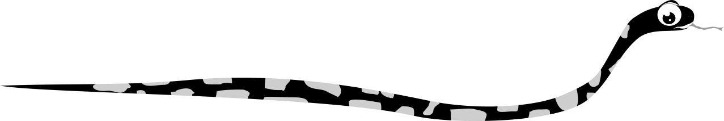
Find the words in the grid.
eyes, ears, legs, paws, claws, beak, feathers, tail, whiskers, mane, fur

R | I | M | R | T | C | E | X | H | M | J | F
G | Y | A | Y | F | A | L | M | F | G | Q | U
F | N | N | C | F | E | W | A | B | K | F | R
R | Q | E | T | C | W | G | A | W | Q | W | L
H | G | I | Q | W | M | X | B | M | S | Q | N
Q | E | K | P | E | H | N | L | B | C | G | C
B | A | L | A | T | N | I | G | E | Q | C | Z
R | R | I | W | S | B | L | S | N | G | I | N
D | S | K | S | K | G | E | S | K | O | S | L
M | U | G | F | N | S | E | A | Z | E | T | F
O | P | Z | G | I | M | R | M | K | Q | R | A
P | L | T | A | I | L | H | T | I | C | W | S
N | Y | R | E | V | X | E | Y | E | S | J | R
A | S | L | V | L | D | X | A | G | S | B | Q
K | F | E | A | T | H | E | R | S | H | B | Q

