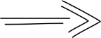
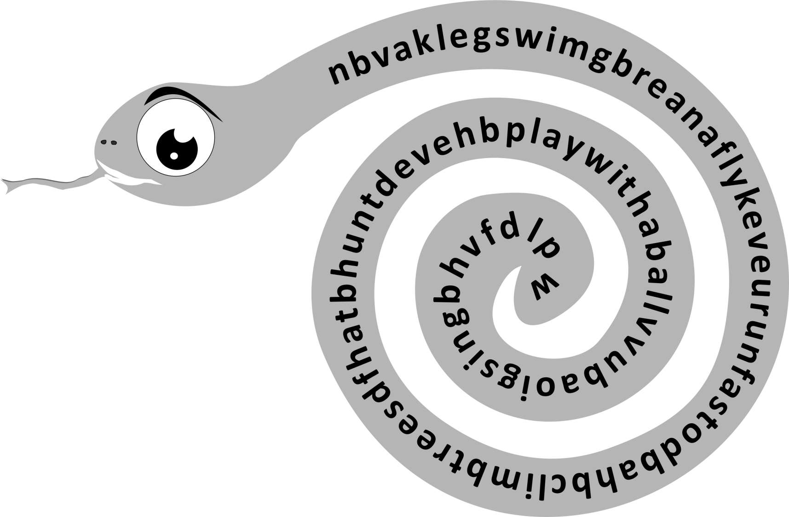
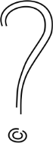
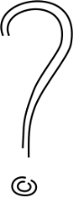
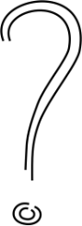
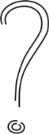
The snake has eaten some words. Find the words.
