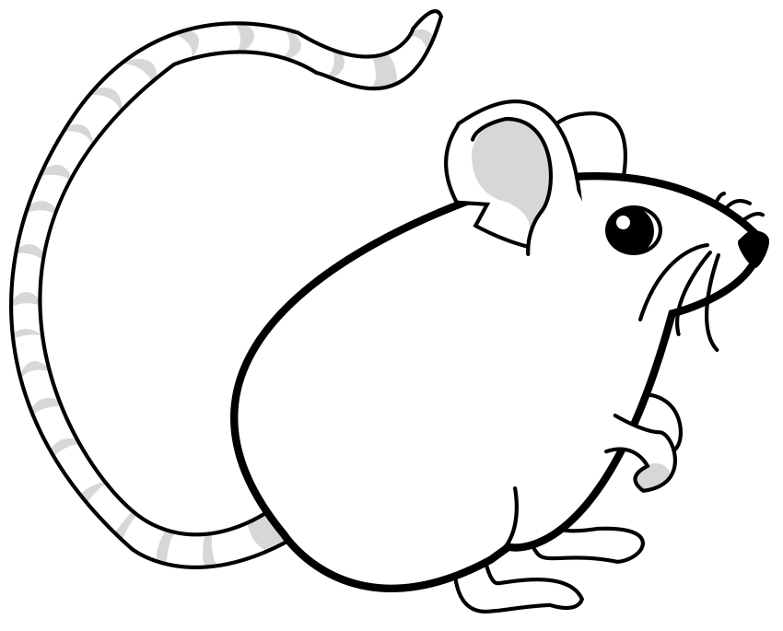
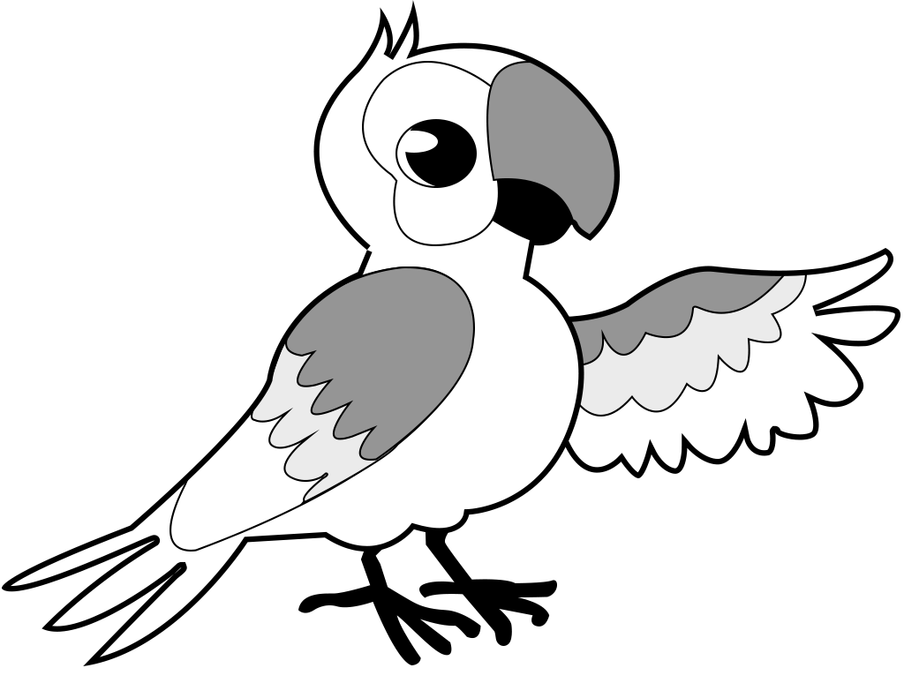
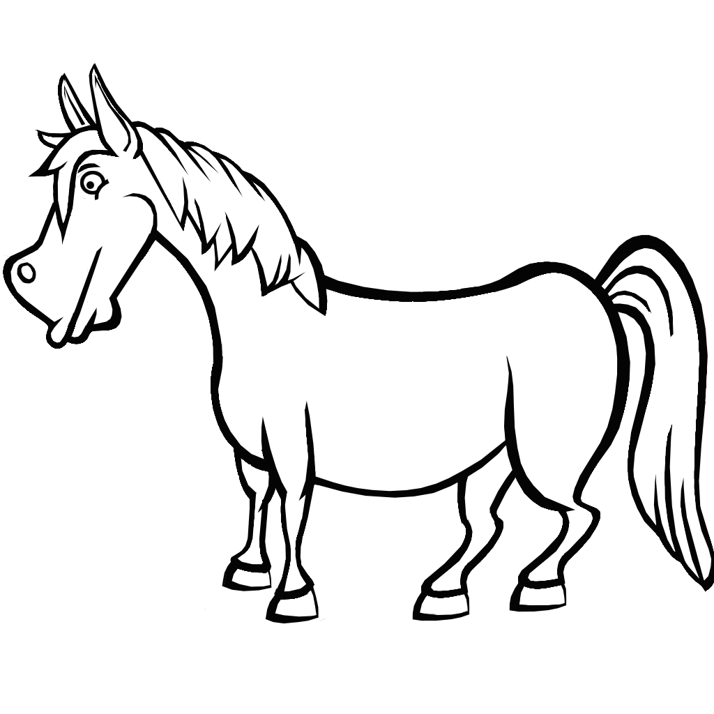
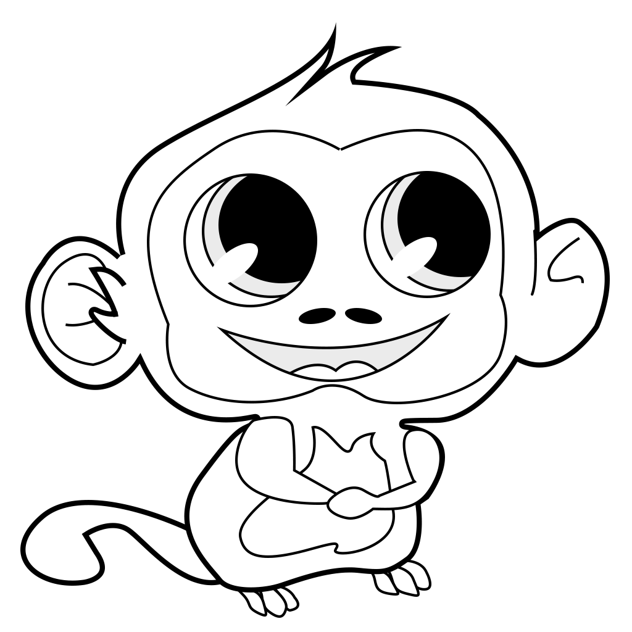
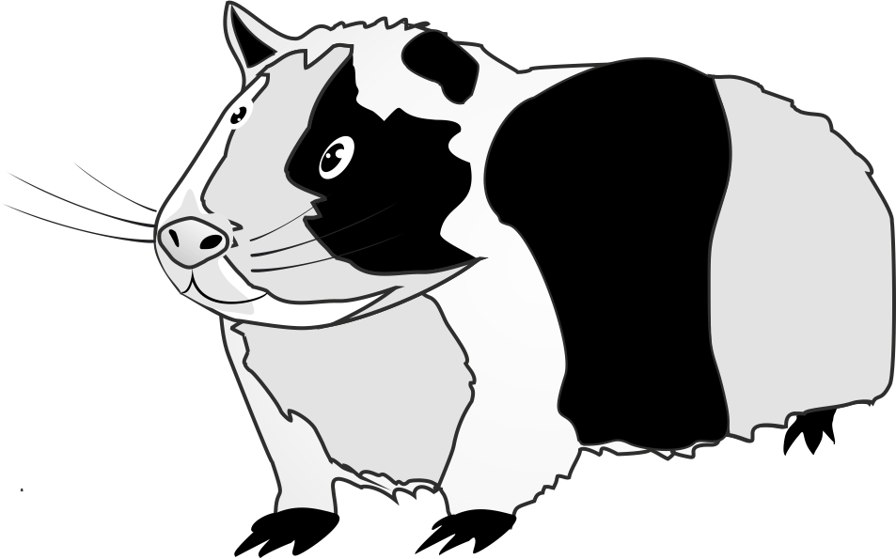

- Read and circle. Red – No, I don’t. Green – Yes, I do.

Do you like
a mouse?
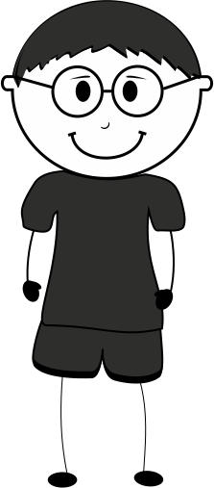

A mouse?
No, I don’t.
Do you like horses?
Horses? Yes, I do.
Do you like parrots?
Do you like elephants?
Do you like monkeys?
Do you like guinea pigs?
Parrots? No, I don’t.
Elephants? Yes, I do.
Monkeys? No, I don’t.
Guinea pigs? Yes, I do.

