CAN YOU…? | ME  ...................... | NAME  ...................... | NAME  ...................... | NAME  ...................... | NAME  ......................
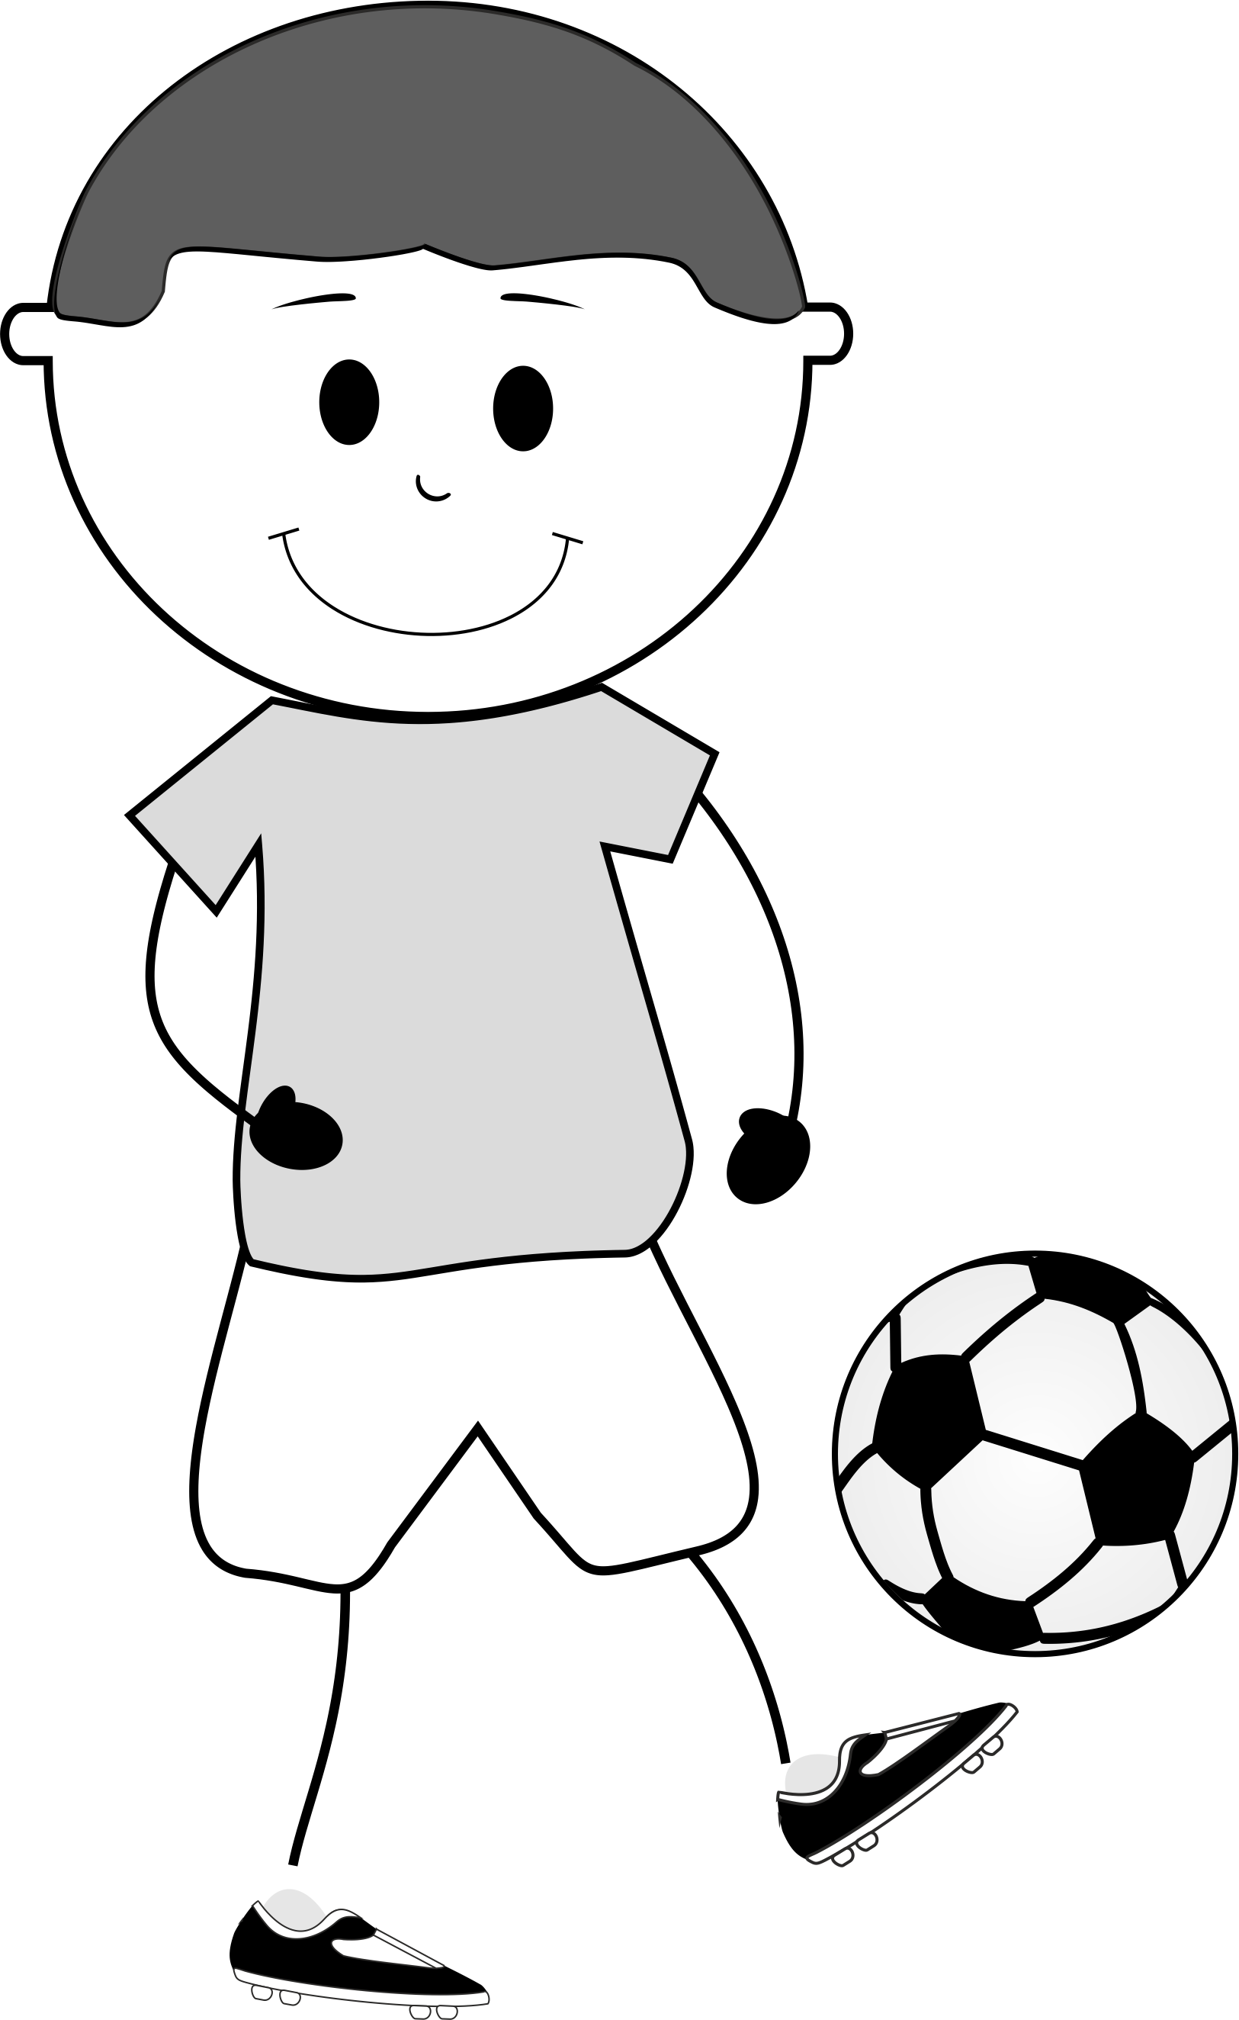
SING
PLAY FOOTBALL
PLAY THE GUITAR
ACT WELL
DRIVE A CAR
SWIM
DANCE |  |  |  | 