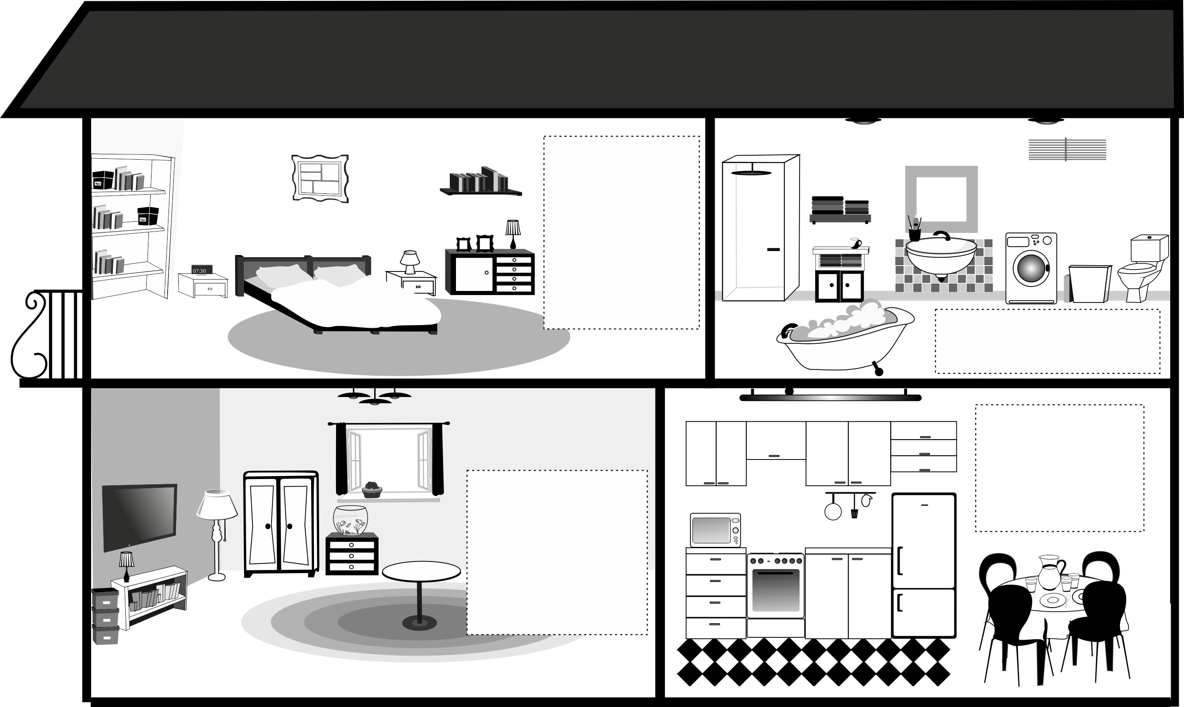
There is a wardrobe in the bedroom. There is a sofa in the living room. There is a rug in the bathroom. There is a window in the kitchen.

- Dorysuj brakujące elementy
w odpowiednich pokojach.

