- Wykreśl słówko niepasujące do innych.
playgroundcomputer labdining hall
runny nosestaff room
staff roommy classroomsports field
computer labgarden
living roomhalllockers
after school clubcloakroom
after school clubtoy shopcomputer lab
dining halllockers
my classroomsports fieldhall
runny nosecloakroom
1.
2.
3.
5.
6.

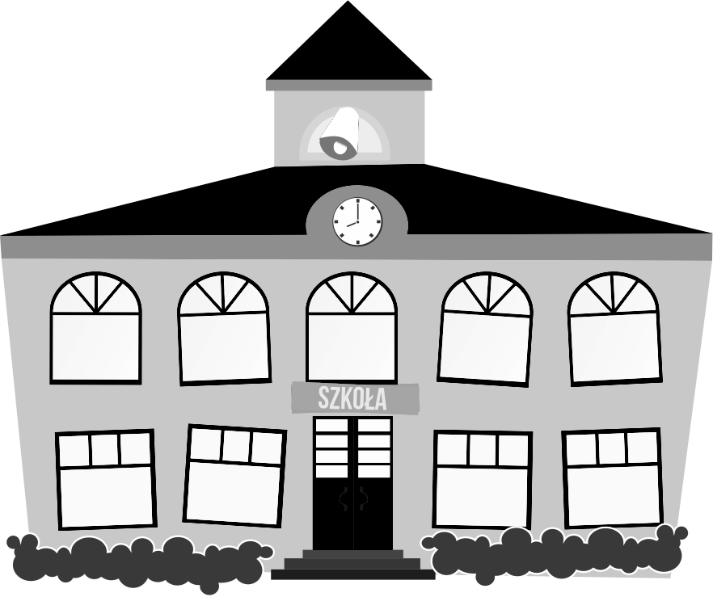
dining hallstaff roompencil case
libraryplayground
4.

