- Wpisz brakujące słówka do dialogów.
Mum: What’s the _____________________ like?
Child: It’s sunny.
Mum: Put on your _____________________ .

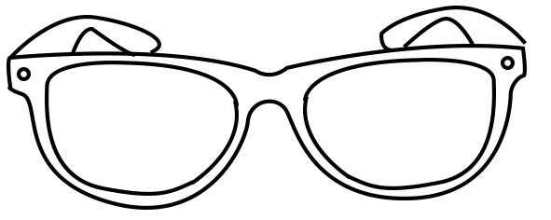

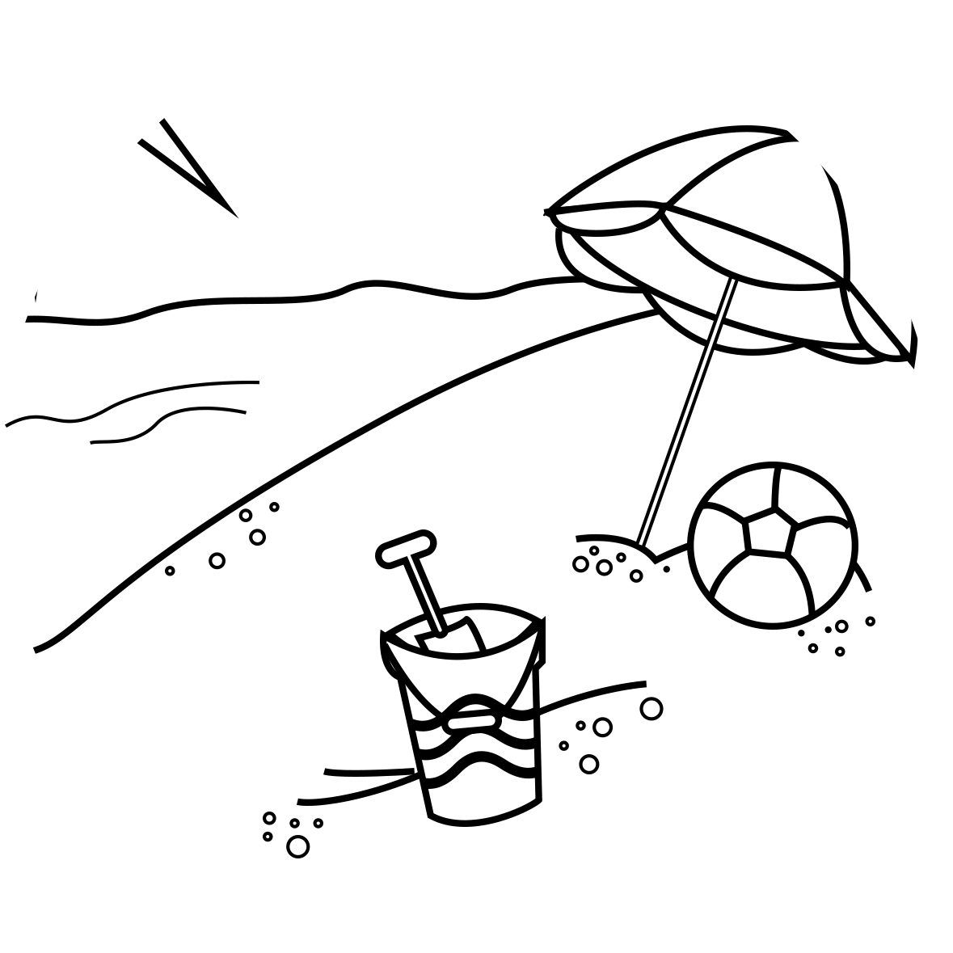

Dad: It's hot. Put on some ________________________.

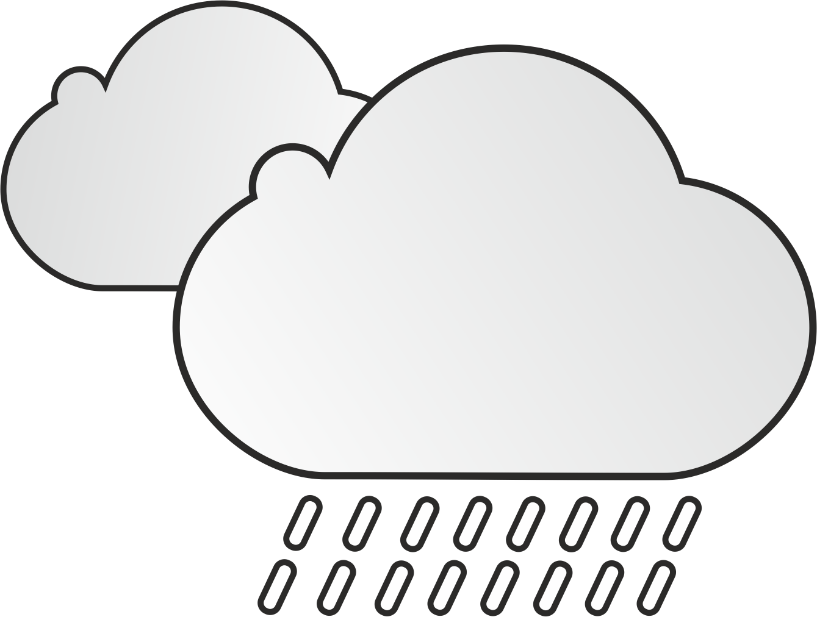
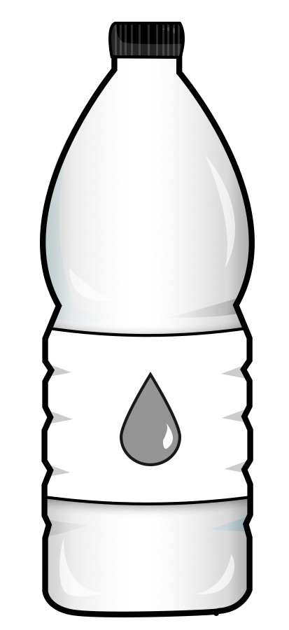
Girl: What’s the weather ______?
Boy: It’s rainy. ______________ your umbrella.
Girl: What’s the weather like?
Mum: It’s rainy. Put on your ______________________ .
Girl1: It’s hot!
Girl2: Drink some ____________________ .

