- Wstaw do dialogów brakujące słówka.

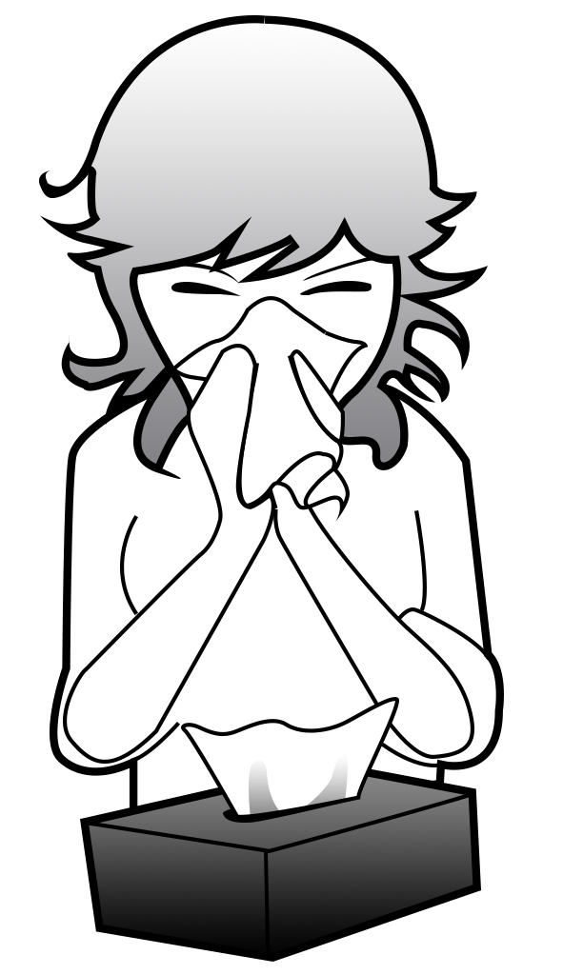
home, down, matter, down, you, nose

D: Hello.
P: Hello.
D: Sit ............................................ .
P: Thank …………. .
D: What is the ............................................?
P: I've got runny ............................................ .
D: Lie ......................... and stay at ............................................ .


thank you, what, leg, have

D: Hello. What is the ......................... .. ?
P: Hello. My ...................................hurts.
D: ................................ a rest and relax.
P: ............................................ .

