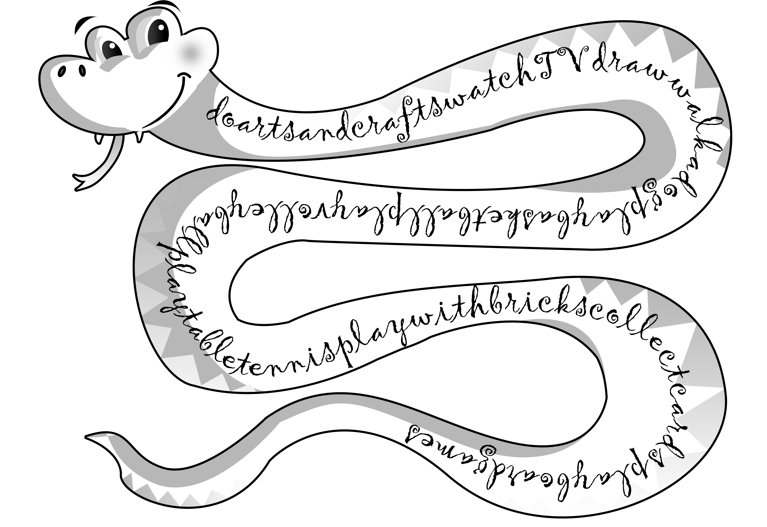
- What do you do in your free time? The snake has eaten some words. Find them!

