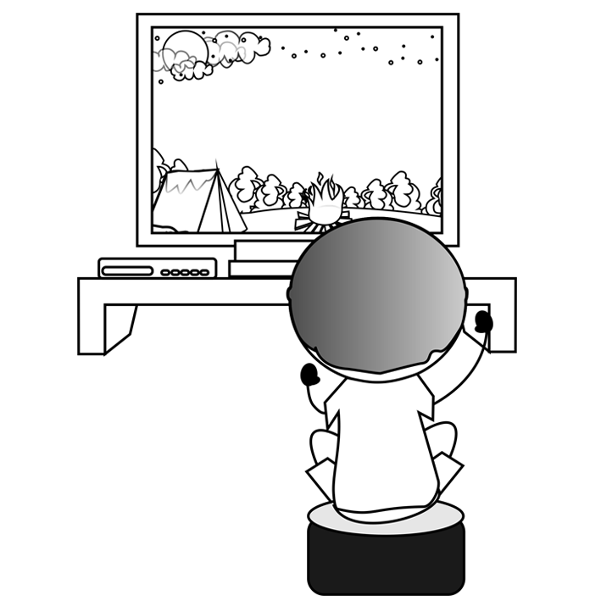
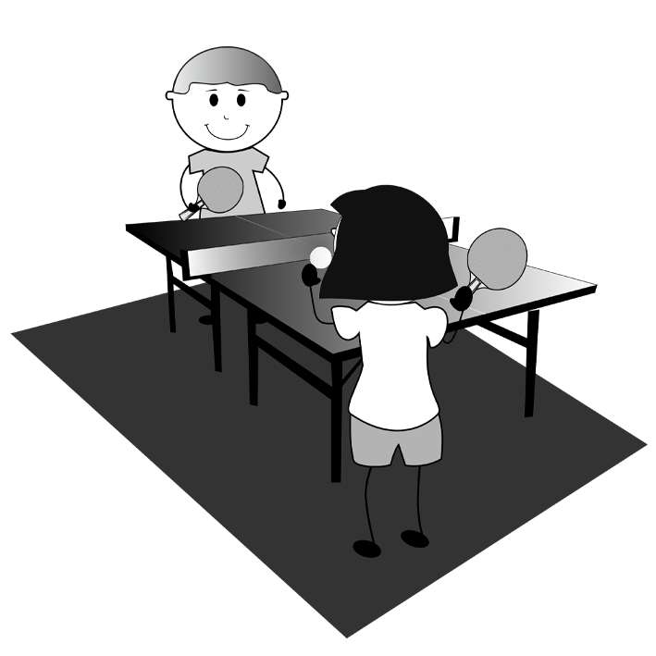
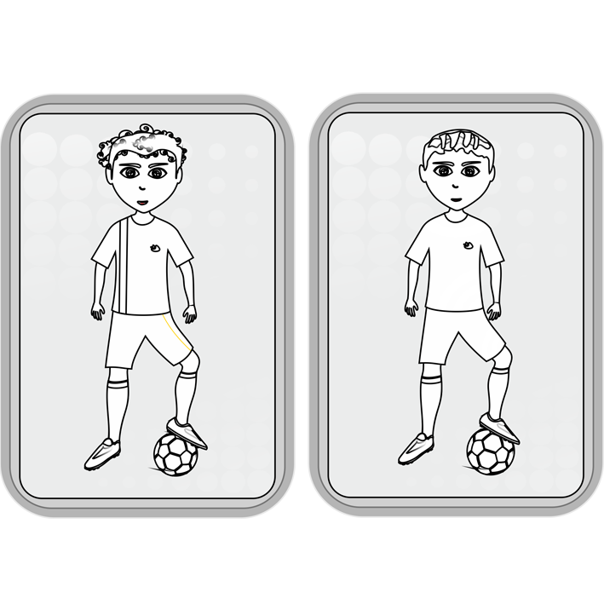
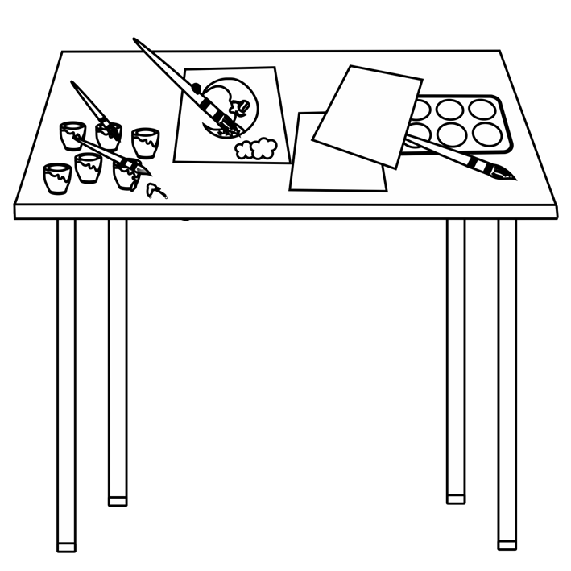
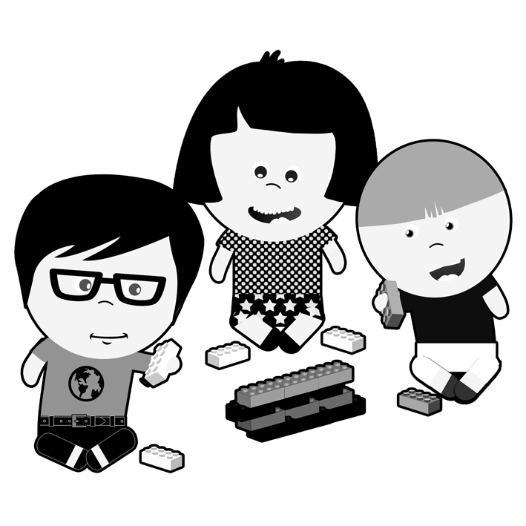
 |  |  |  |  |  |  |  |  |  |  |  |  | 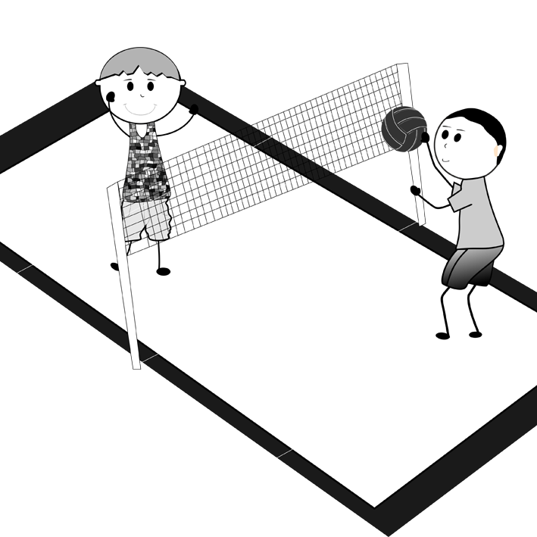
 |  |  |  |  |  |  |  |  |  |  |  |  |  |  |  |  |  | 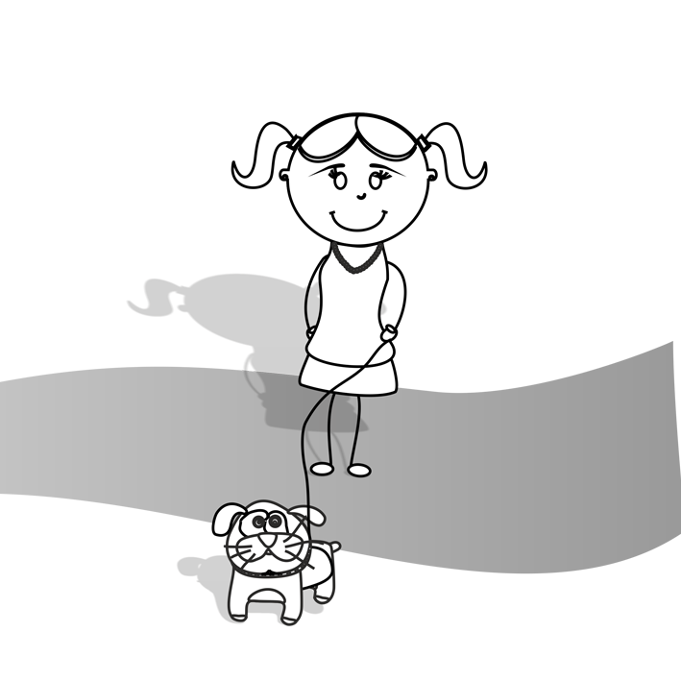
 |  |  |  |  |  |  |  |  |  |  |  |  |  | 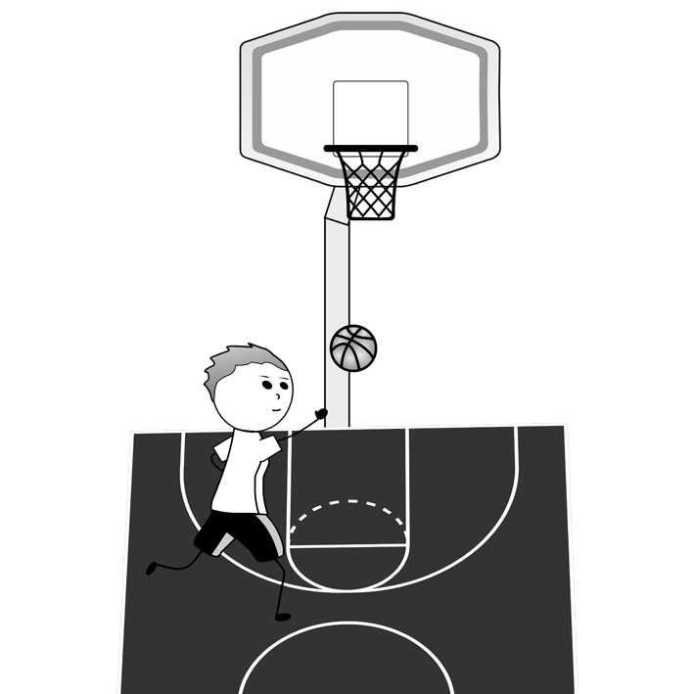 |  |  |  |  | 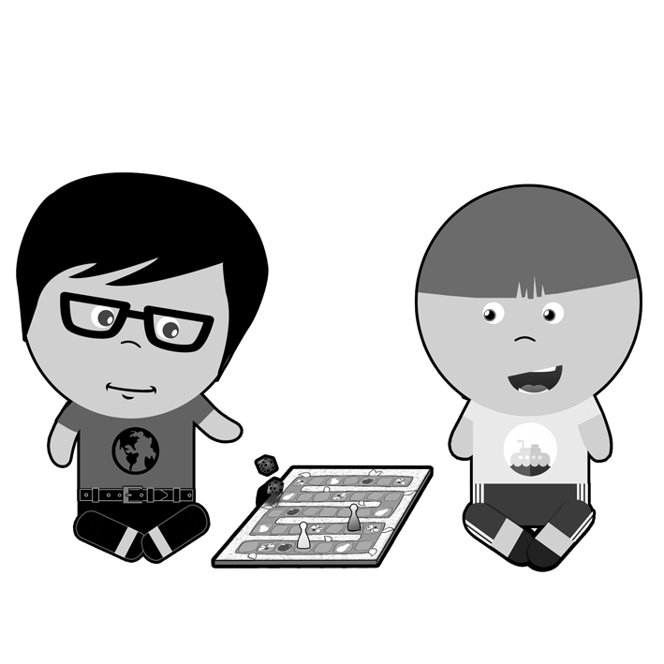 |  |  |  |  | 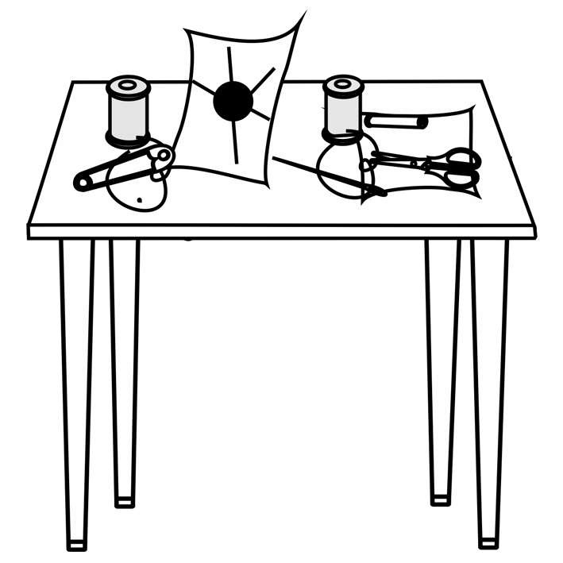
4.
7.
10.
3.
6.
5.
9.
2.
1.
1.
7.
3.
10.
6.
8.
2.
8.
5.
4.
9.

