- Read full messages. Write text messages.

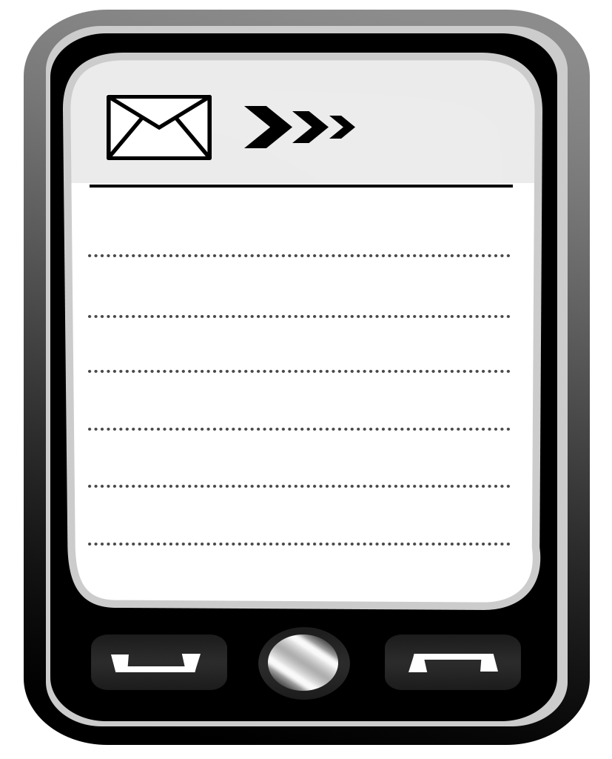
Hi:) How are you ? Today I’m on a camp.
I’m hanging out with friends. And you?
Bye for now.

Hi:) I’m at my grandparents’ today.
My granddad is singing. Laugh out loud!
And you? How are you? Hugs and kisses!

