PART A - Say what the children are doing. e.g Ann is eating ice-cream.
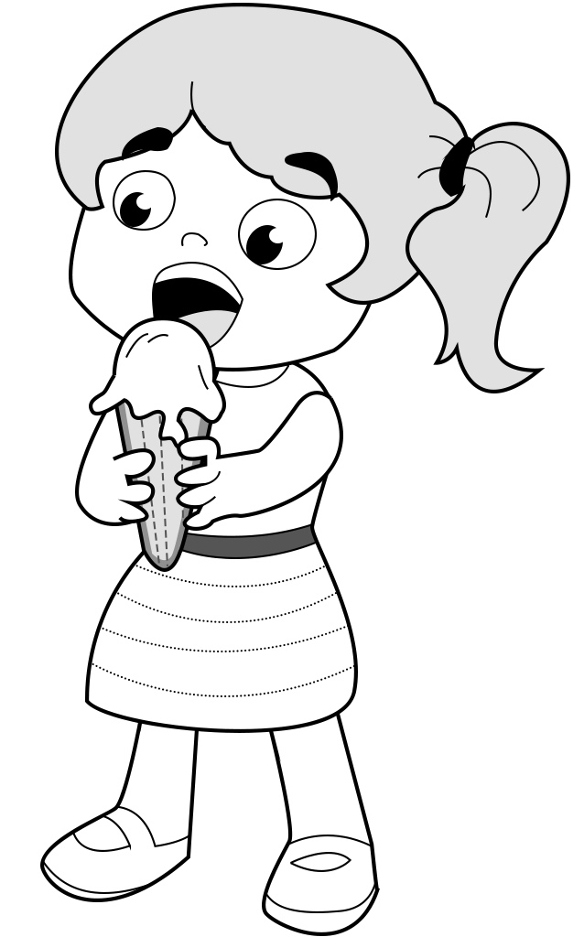 |  | 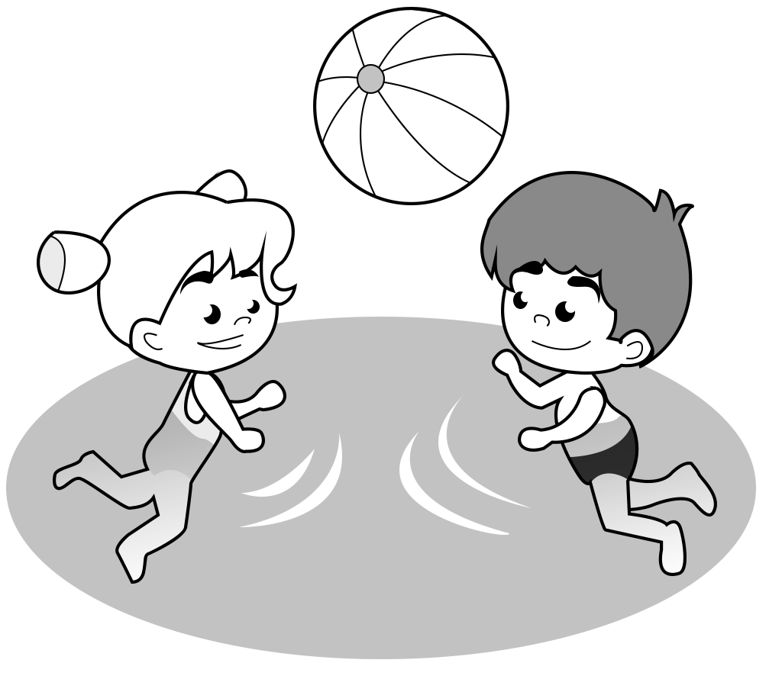
Ann | Jim | Beth and Sarah
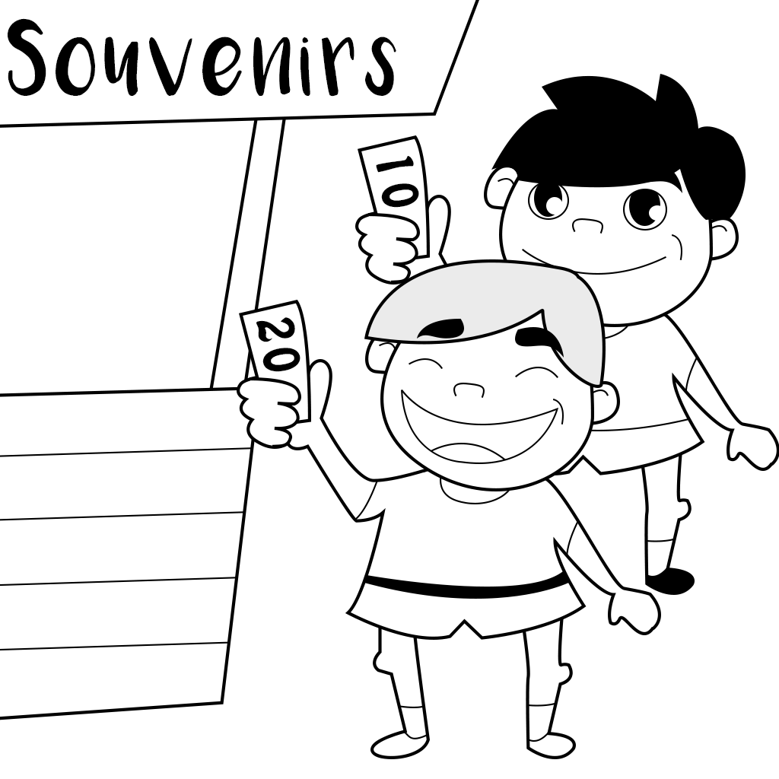 | 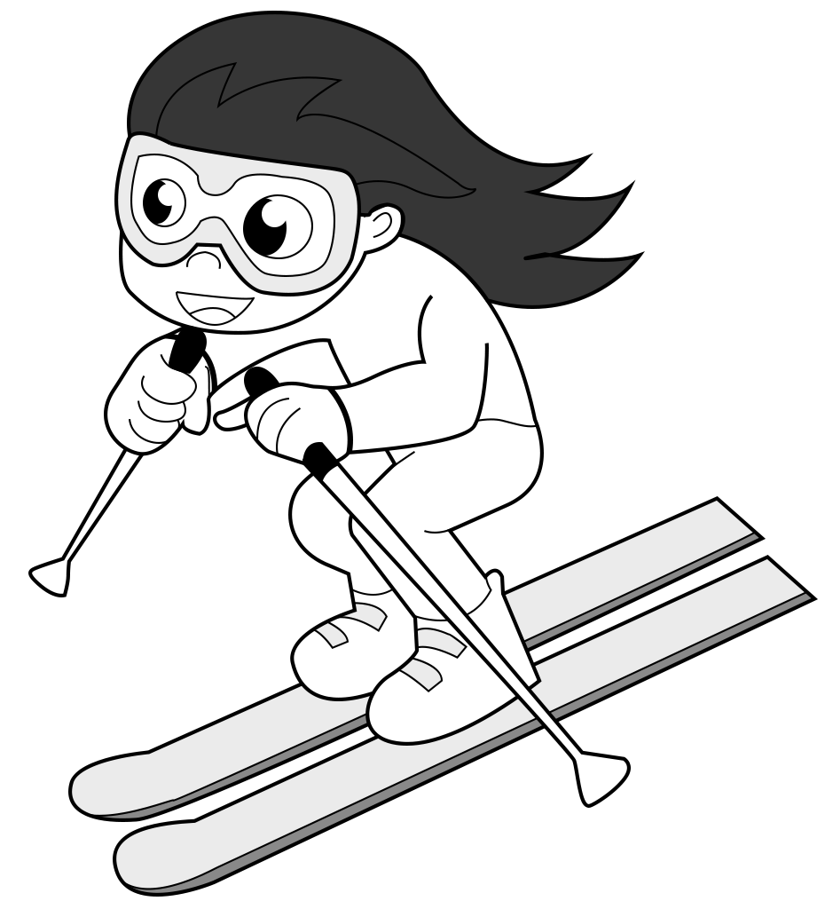 | 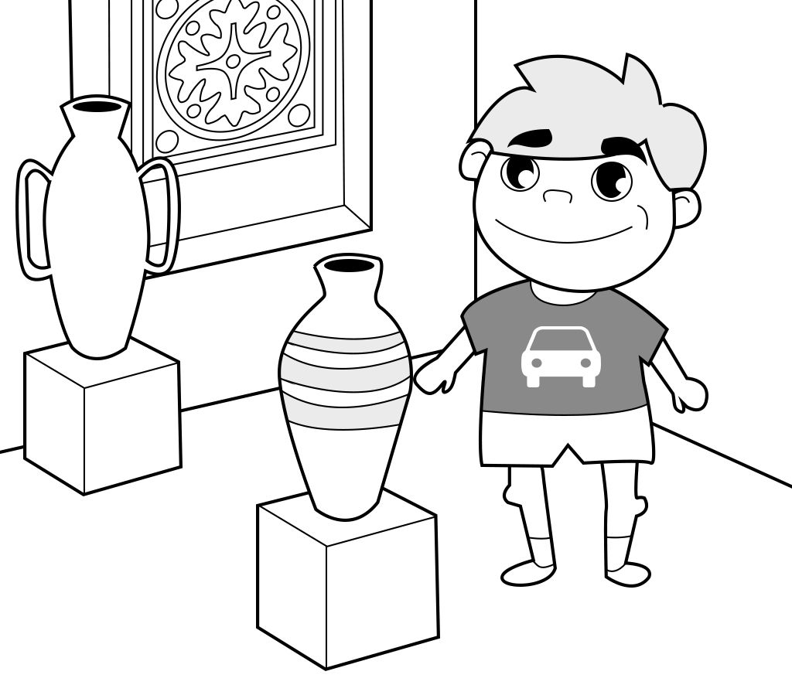
John and Rob | Elly | Tommy

PART B - Listen to your friend. Write the names.
..................................... | .................................... | ...................................
................................... | .................................... | ...................................

