PART A - Say what the children are doing. e.g Mike is hanging out with friends.
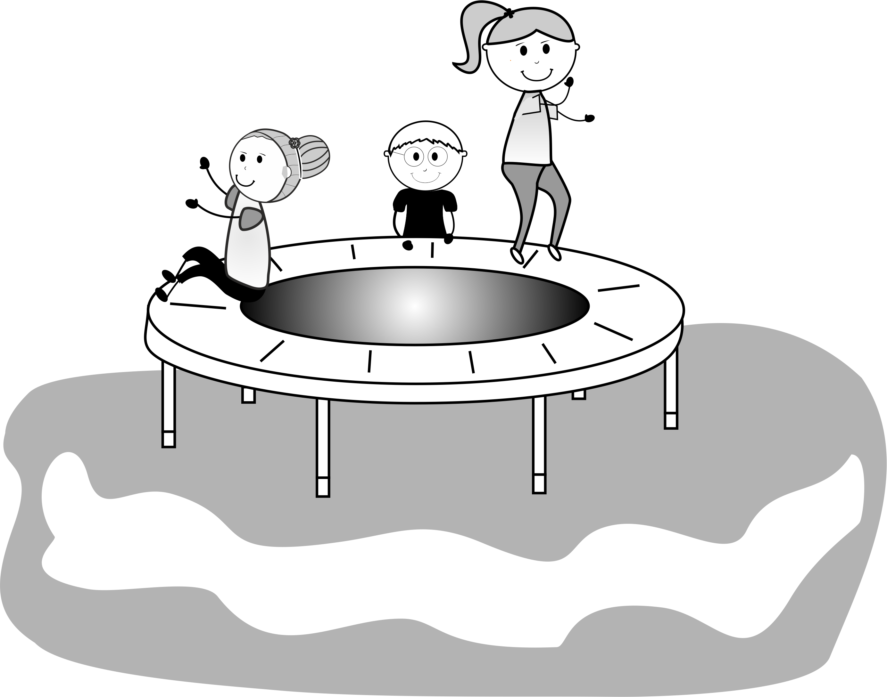 | 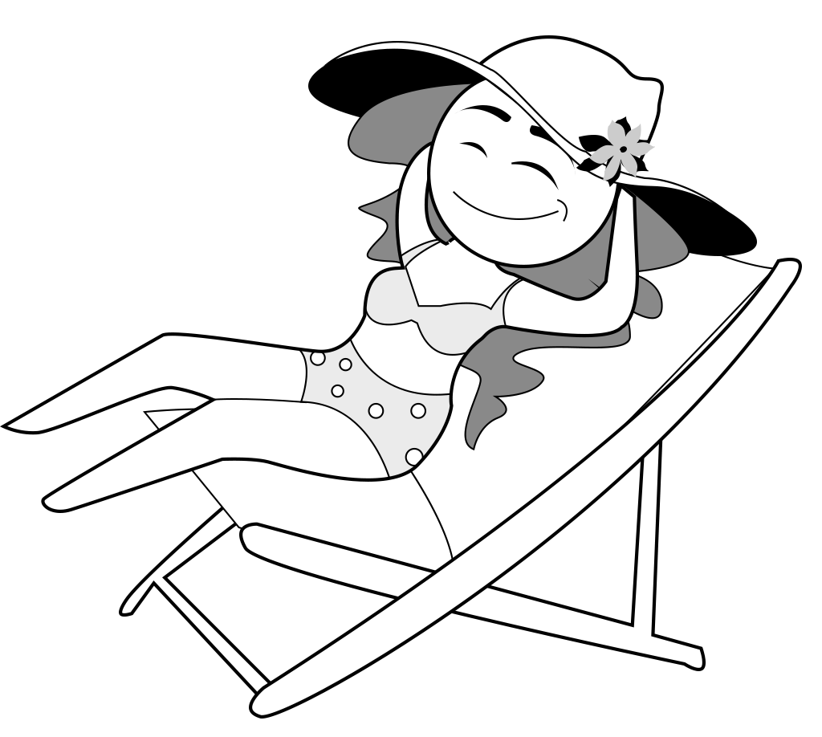 | 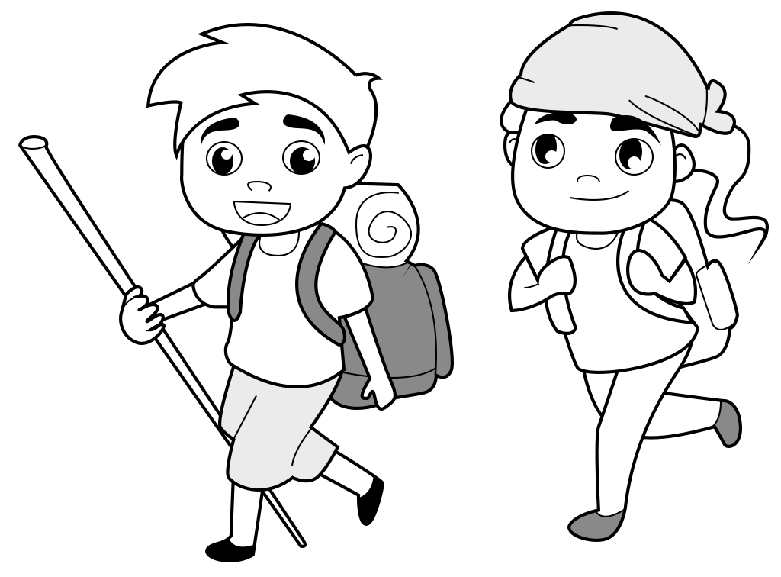
Mike | Kate | Pete and Tara
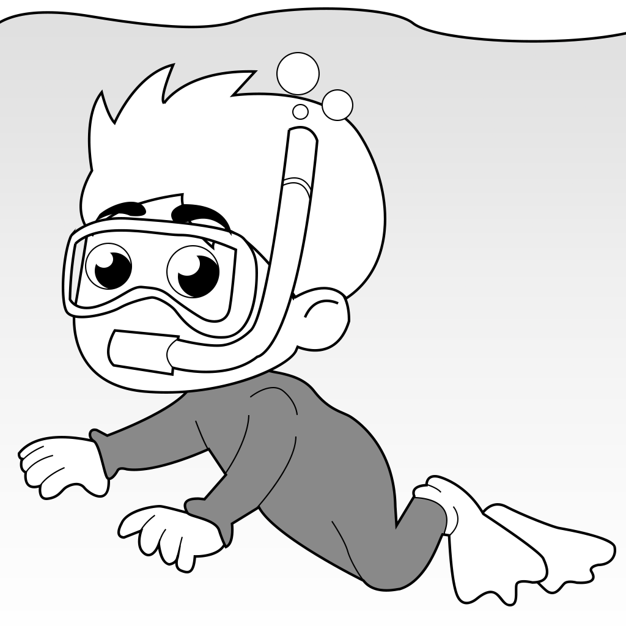 | 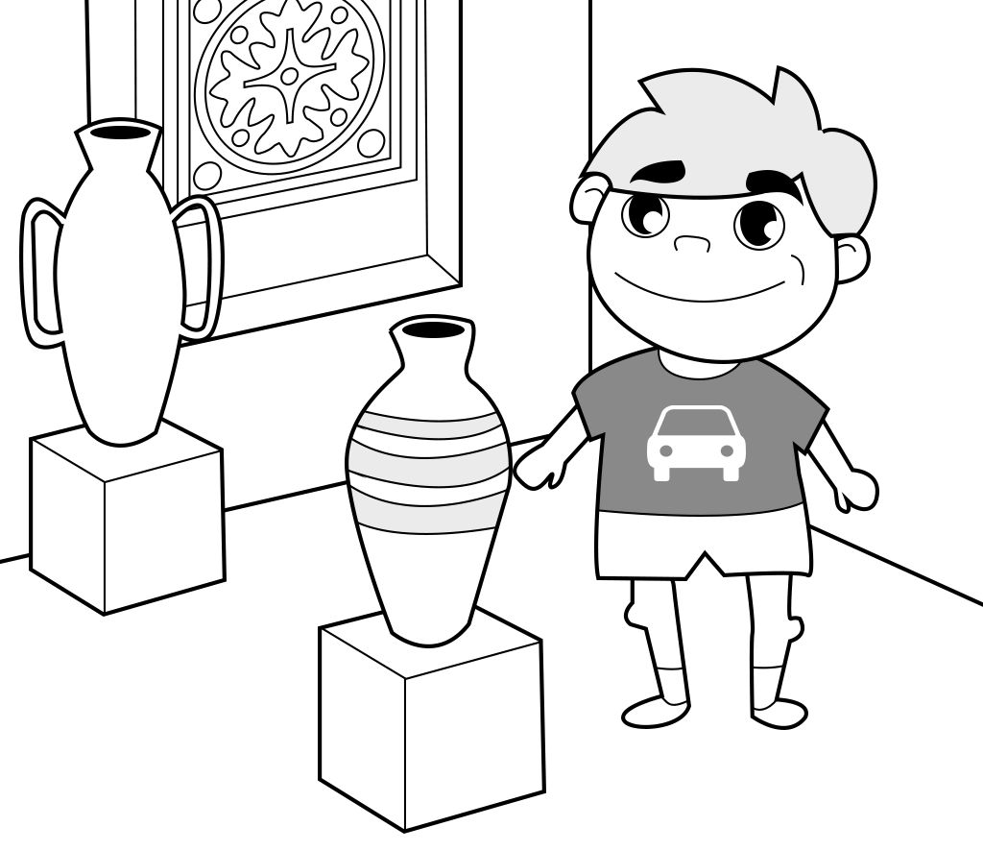 | 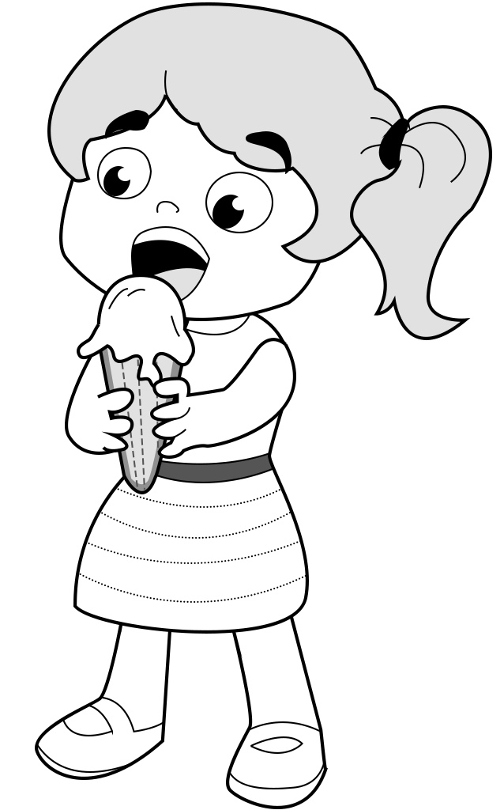
Tim | Jamie | Rosie

PART B - Listen to your friend. Write the names.
.................................. | .................................. | .................................
.................................. | .................................. | ..................................

