PART A Write:
visit / do / on the beach / with friends / take /
/ play / ice-cream / hiking / snorkel / souvenirs
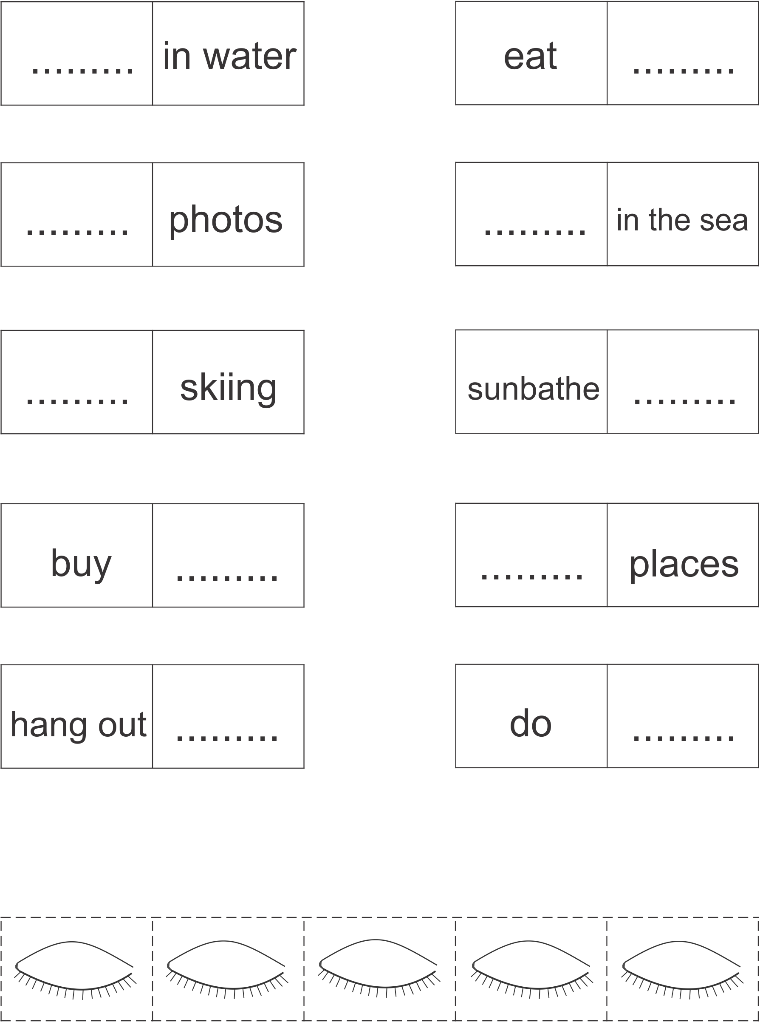

PART B Cut and cover the words in PART A

