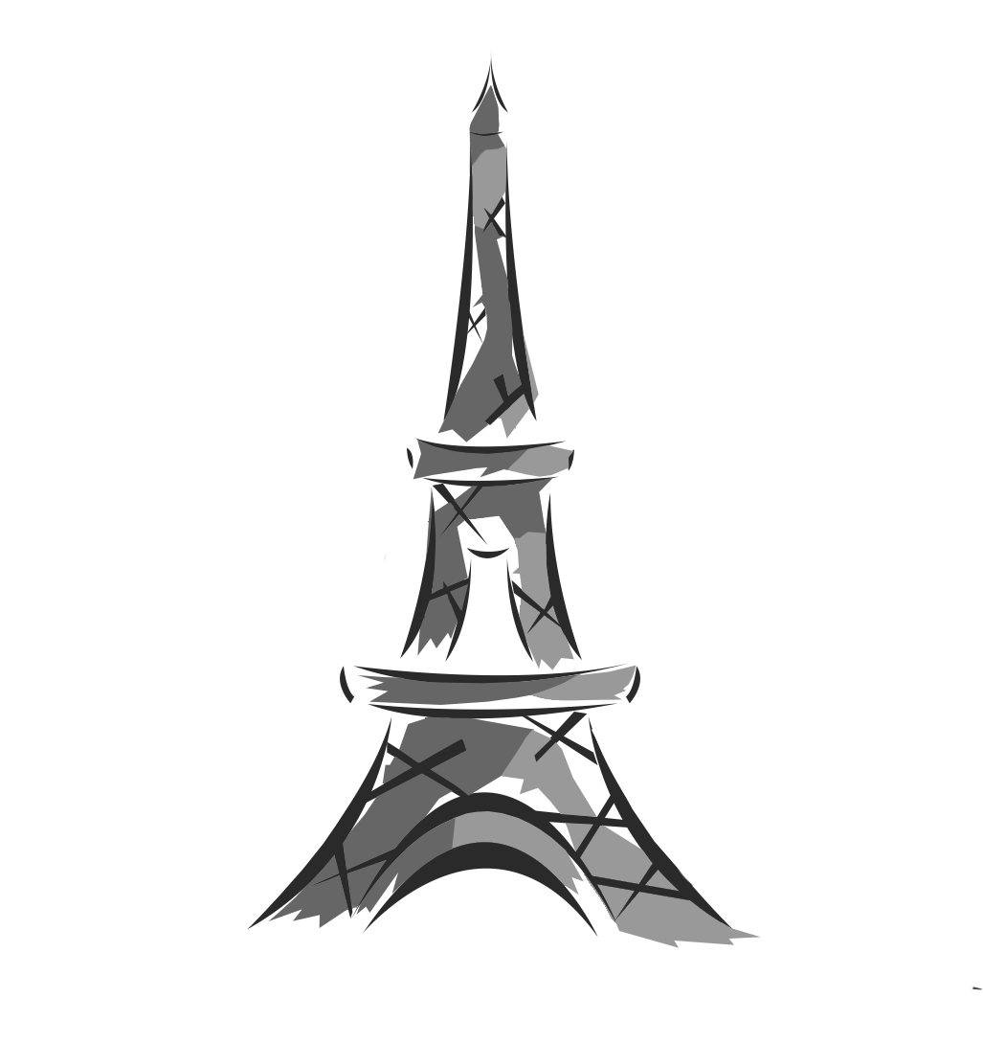
- Circle the correct phrase.
I'm at the seaside/ in the mountains/ abroad.
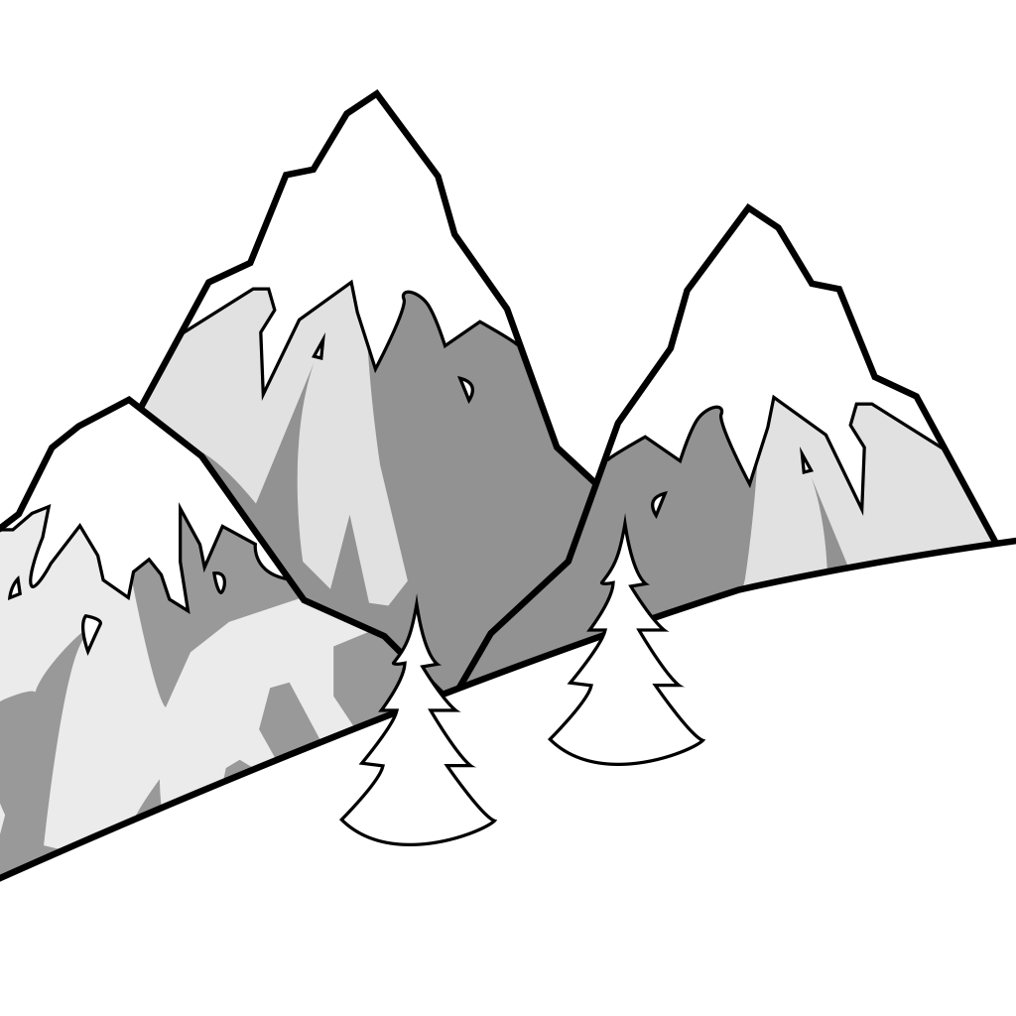
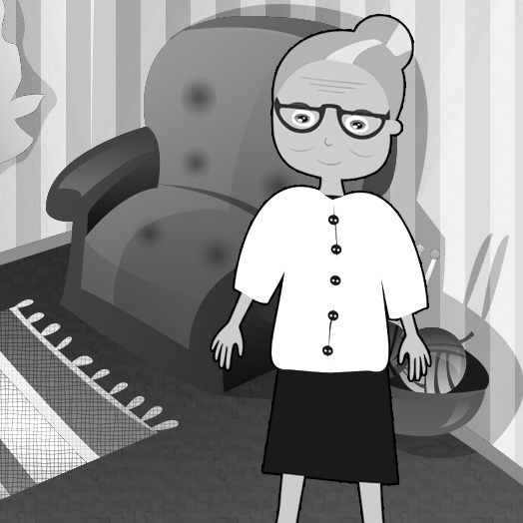
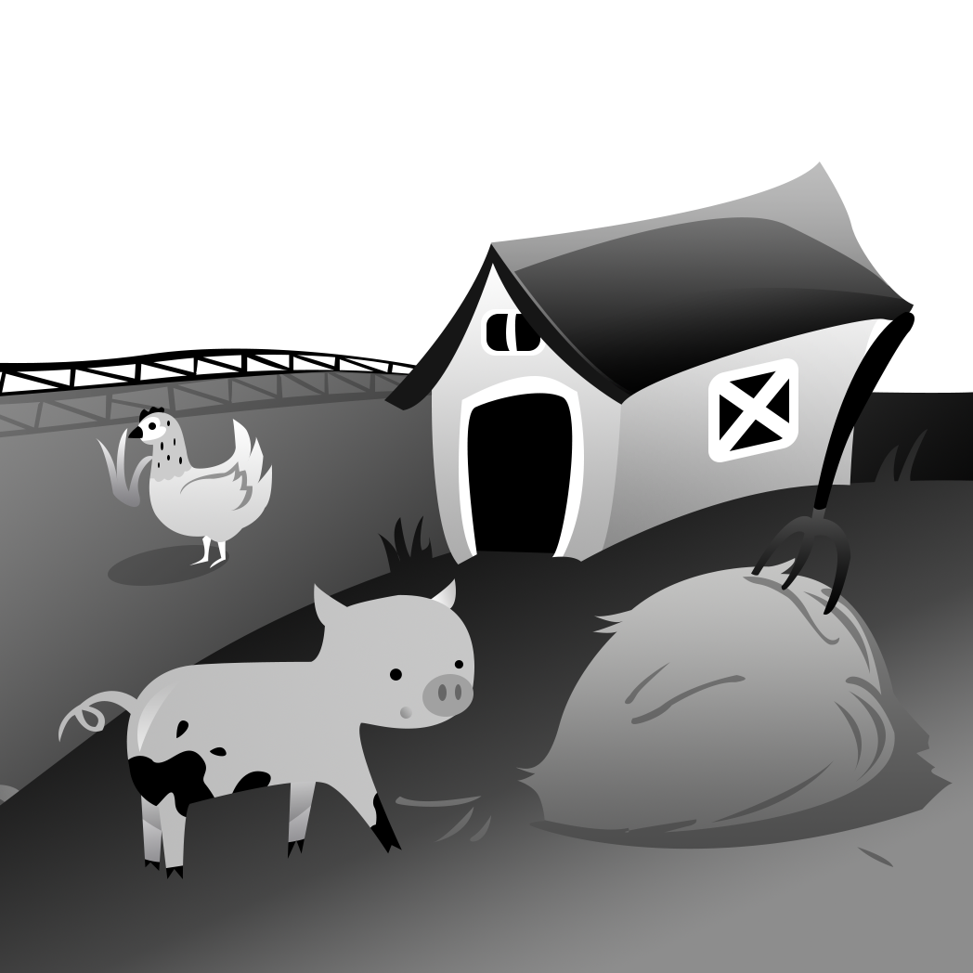
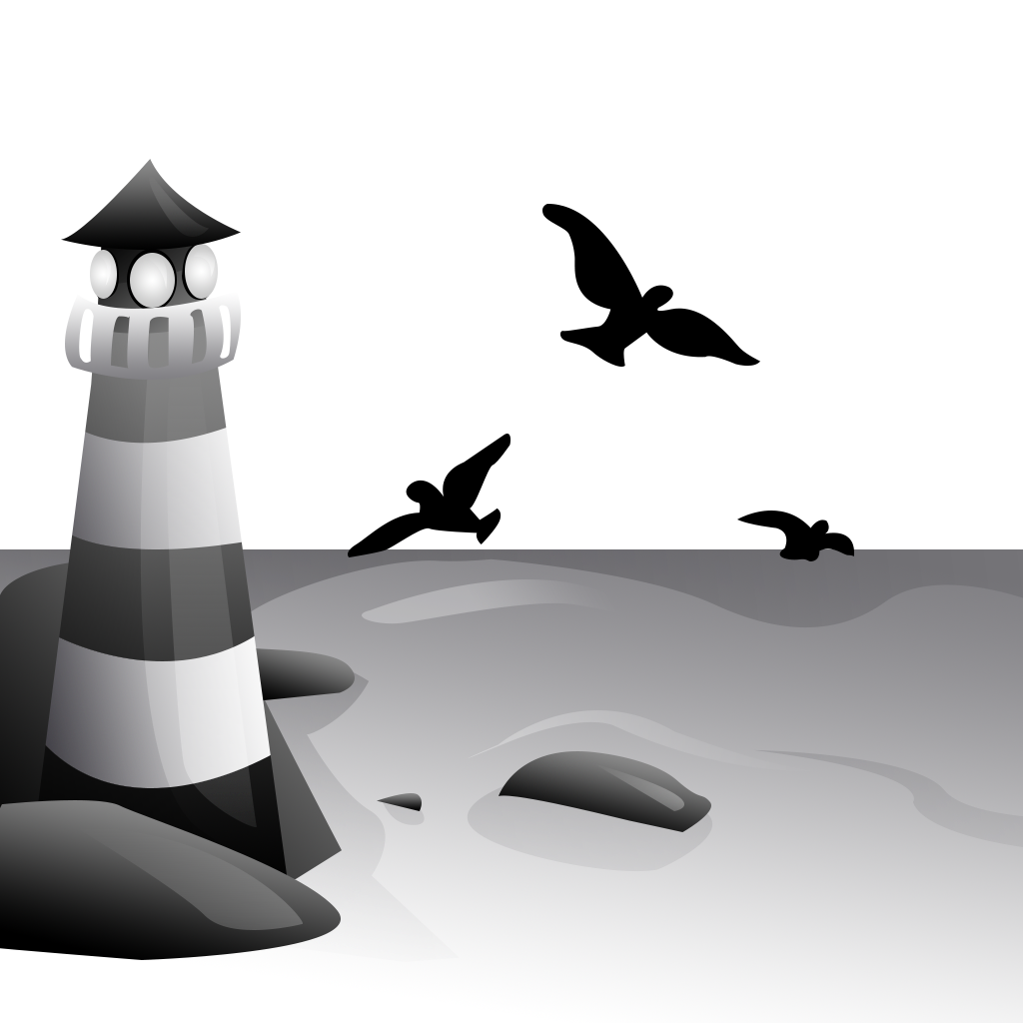
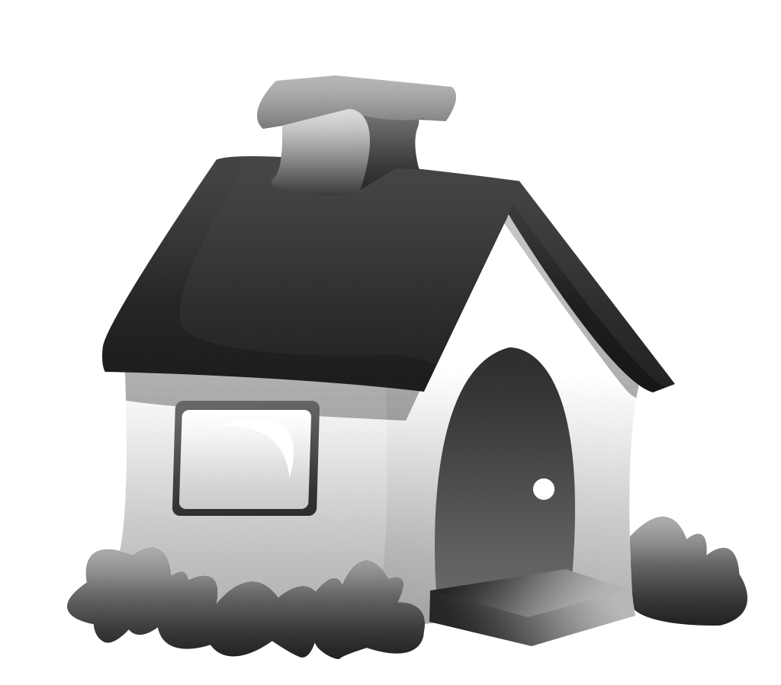
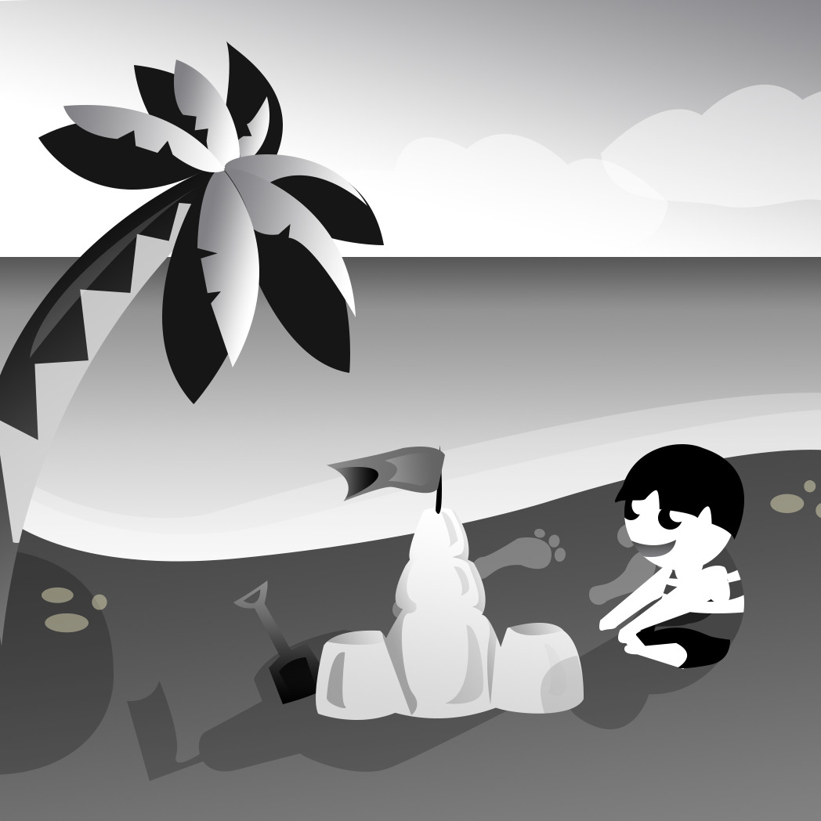
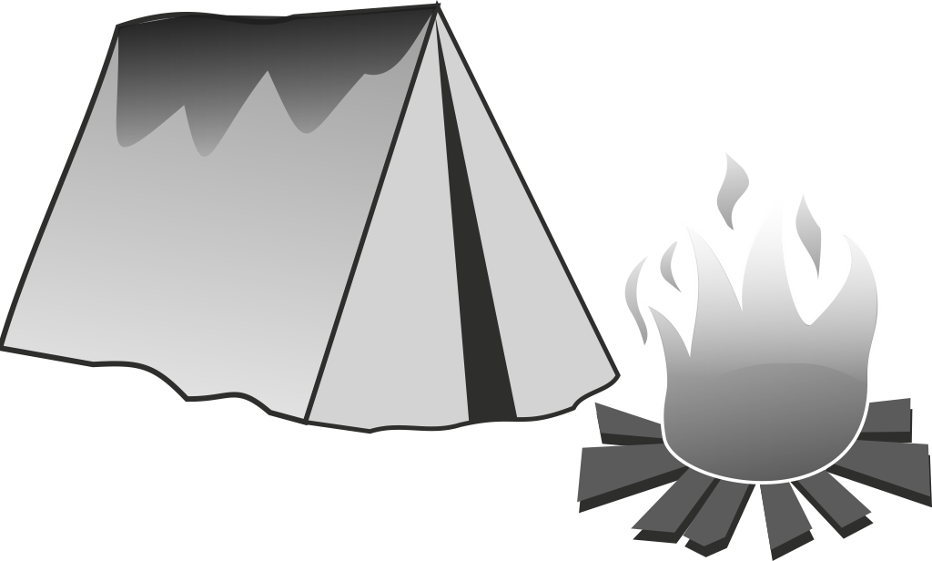
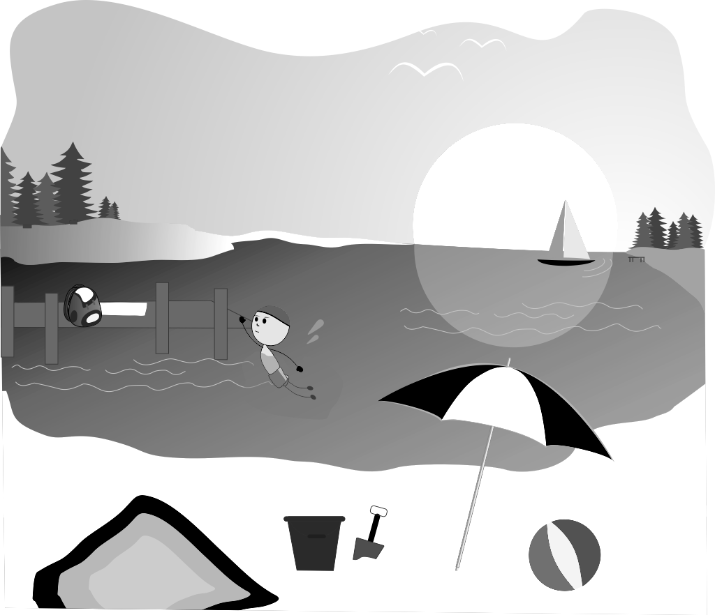
I'm on a camp / at my grandparents/ by the lake.
I'm in the mountains/ in the country/ at home.
I'm on the beach/ in the country/ abroad.
I'm at home/ at the seaside/ on a camp.
I'm at home/ in the country/ at the seaside.
I'm in the mountains/ by the lake/ on the beach.
I'm on the camp/ at the seaside/ abroad.
I'm by the lake/ at home/ on the beach.

