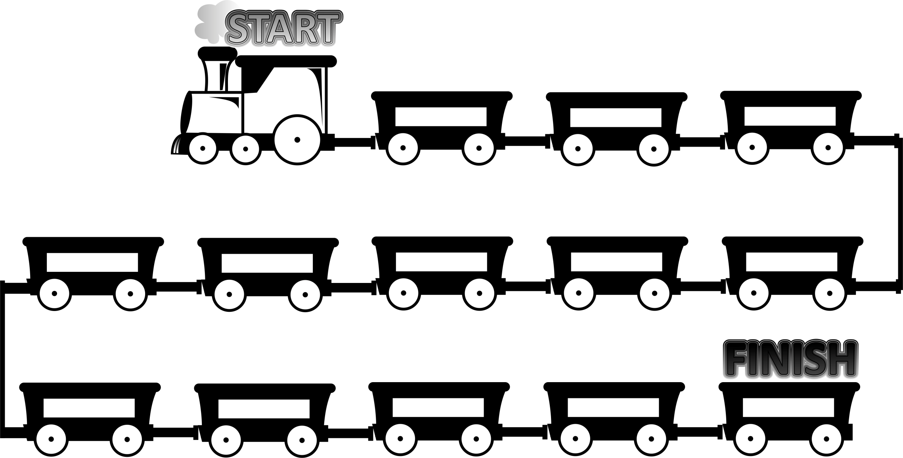

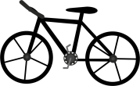
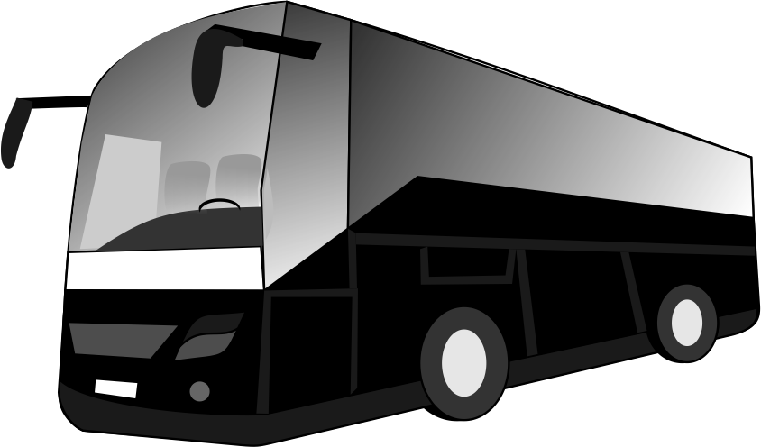
I get to school 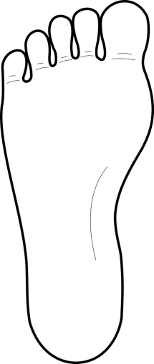

How do you get
to school?
It’s a
It takes me

.................................
minutes to get to school.
How long does it take you to get to school?
I get to school
..................................
It’s a

How do you get
to school?

I ……………….............
to school by car.
How long does it take you to get to school?
It’s a

It .............................
me 10 minutes to get to school.

