Student A - Ask your friend and draw the missing buildings on map.

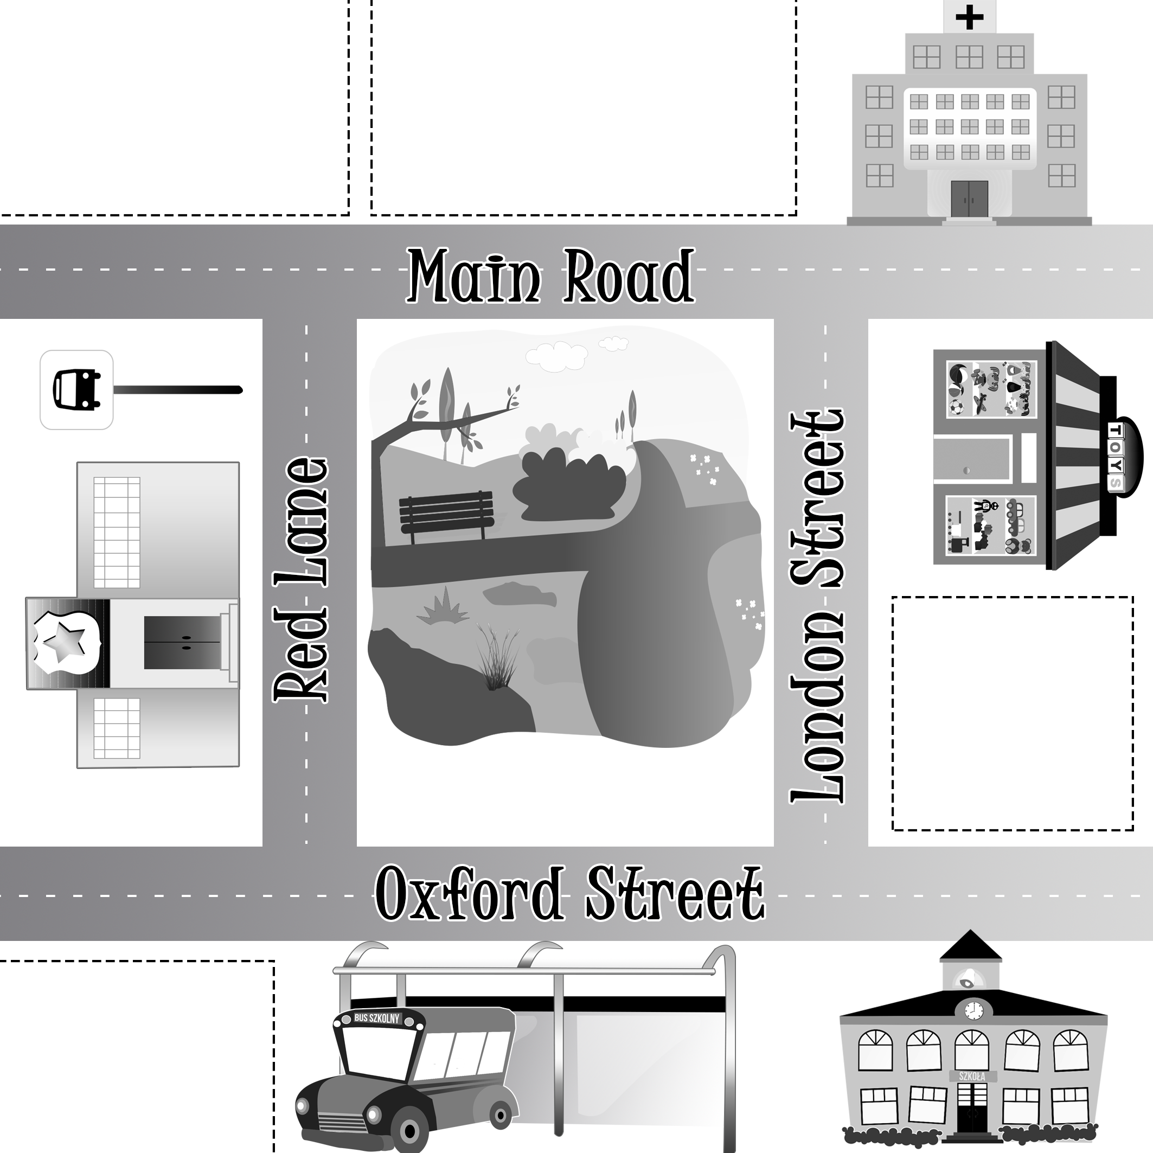

Student B - Ask your friend and draw the missing buildings on map.

