 |  |  |  | 4. |  |  |  |  |  |  |  |  |  | 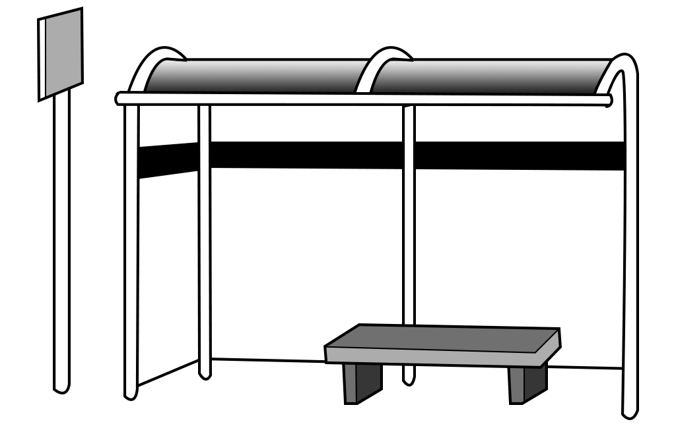  1.
 | 1.
 |  |  |  |  |  |  |  | 5.
2. |  |  |  |  |  |  |  |  |  |  |  |  |  | 6.
3. |  |  |  |  |  |  |  |  |  |  |  |  | 6. | 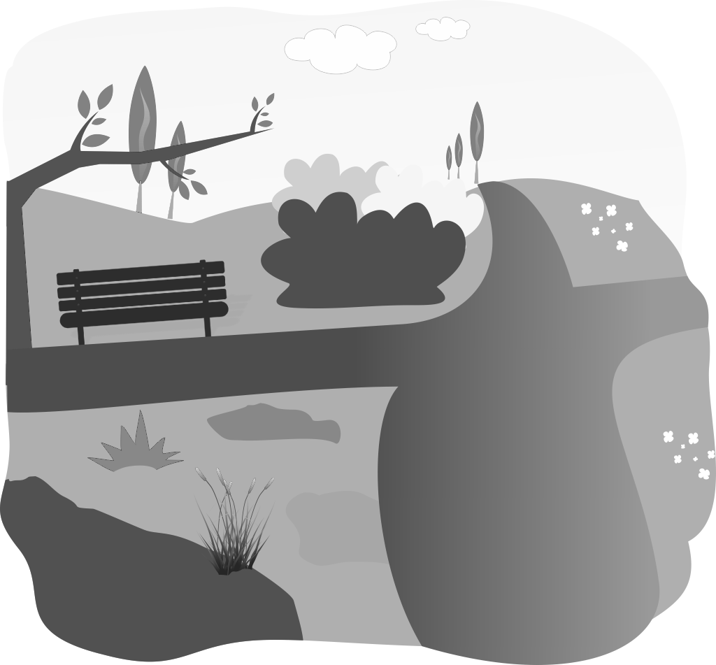
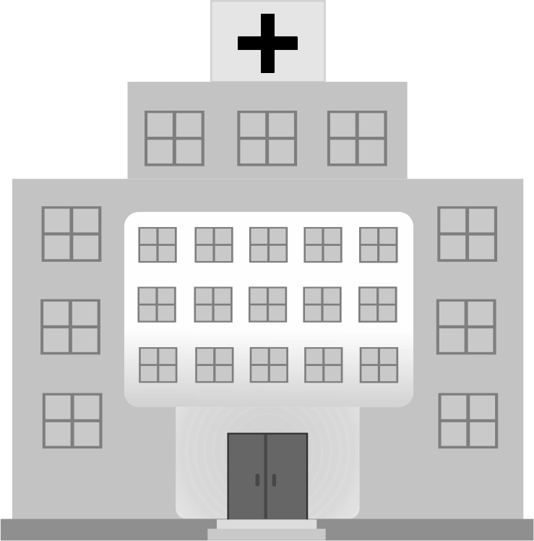
 |  |  |  |  |  | 3.
 |  | 5. |  |  |  |  |  | 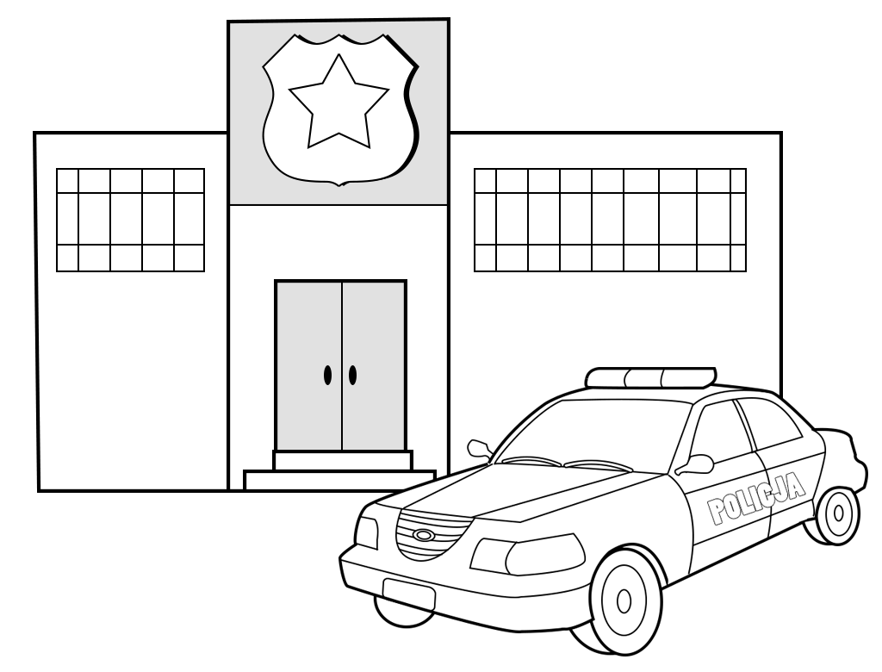  2. |  |  |  |  |  | 4.
 |  |  |  |  |  |  |  |  |  |  |  |  |  | 