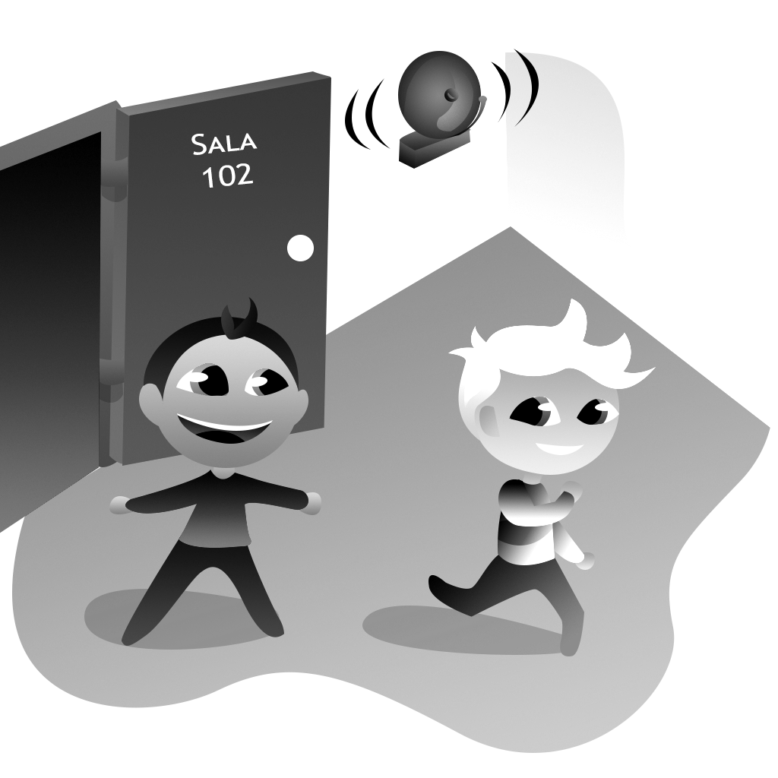
Q: What time do you .......................................?
A: ..................................................................... .
Time:
Q: What time do you .......................................?
A: ..................................................................... .
Time:

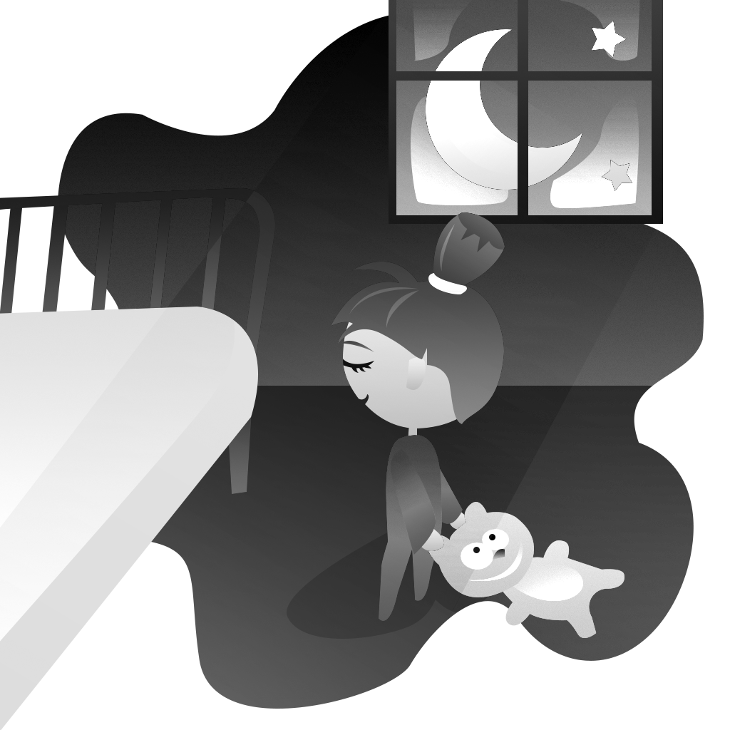
Q: What time do you .......................................?
A: ..................................................................... .
Time:
Q: What time do you .......................................?
A: ..................................................................... .
Time:

