- Put the words in the correct order.
play – Why – we – don’t – board game - ?

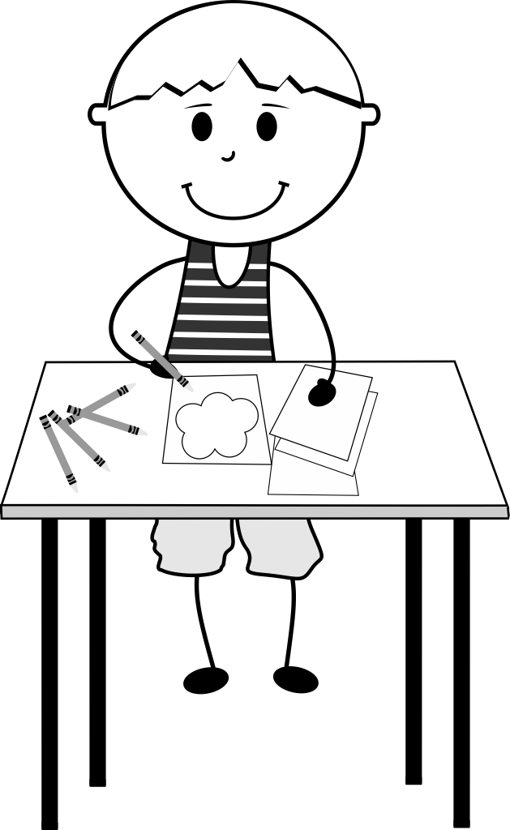
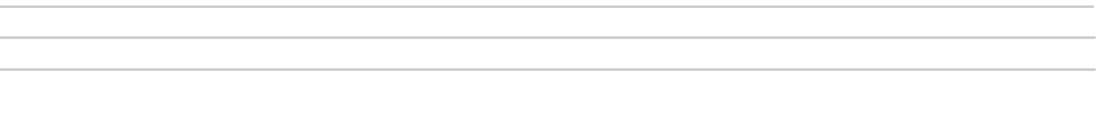
don’t - drawing – like – I

you – doing – What– do – like - ?

flight– What – your – is – time - ?

you – How – to – do – school – get - ?
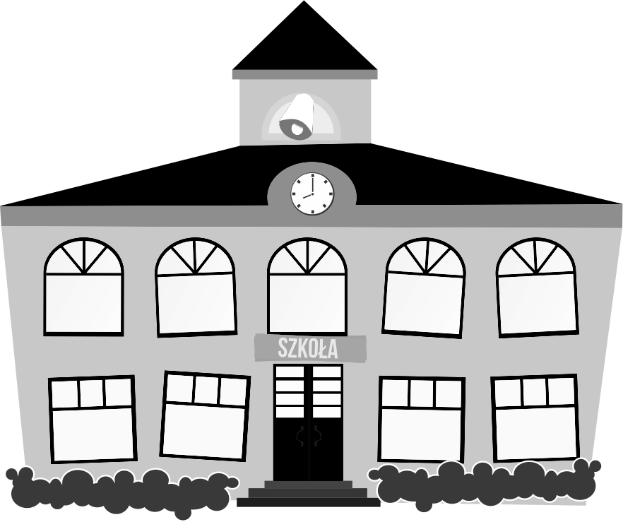
TV – Let’s - watch

to - takes – It - me – 15 minutes – to school – get

