- Put the words in the correct order.
you – like – Would – juice – some - ?

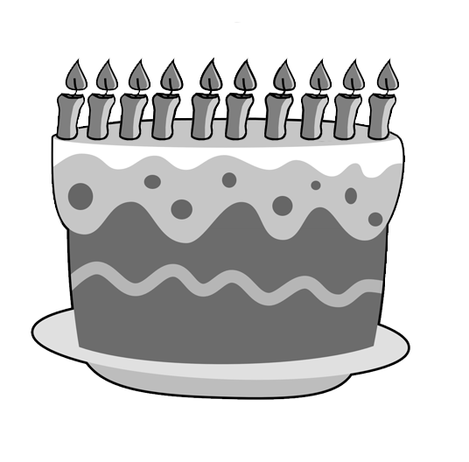
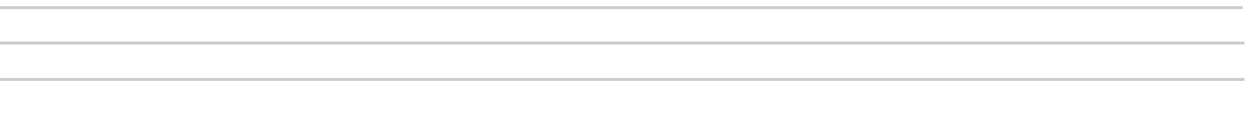
some – cake – Have

the salt – please – Can – pass – me – you - ?

time – you – get - What – up – do – Sunday – on - ?

is – What – it – time - ?

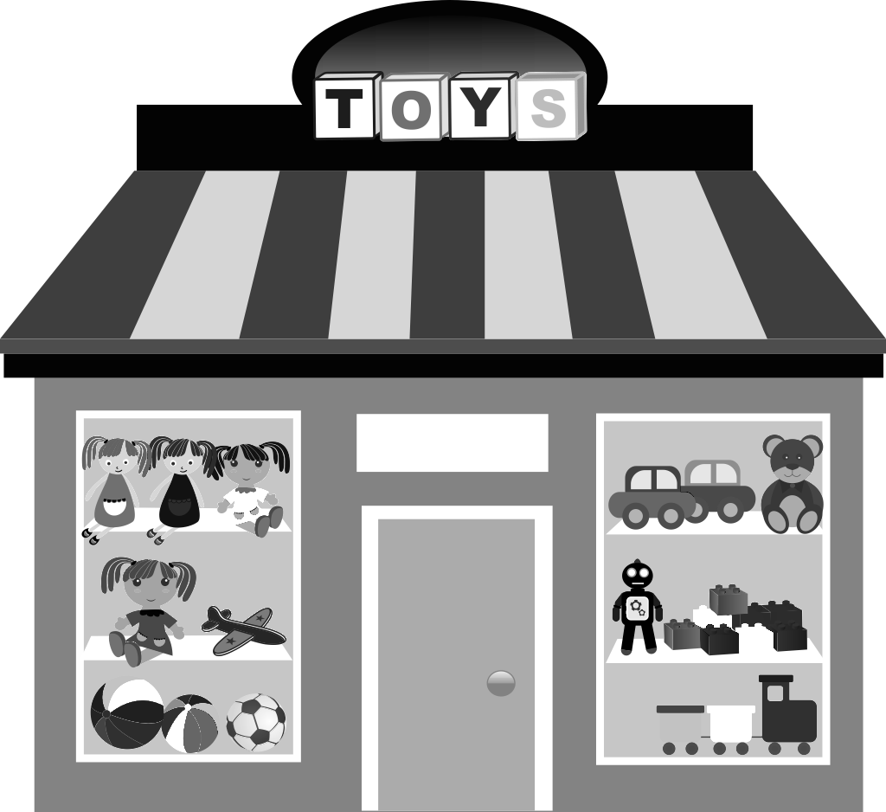
The school – between – the newsagent’s - is - and – the toy shop

are – three – shopping centres – There – in – town - my

