PART A Choose the correct ending.

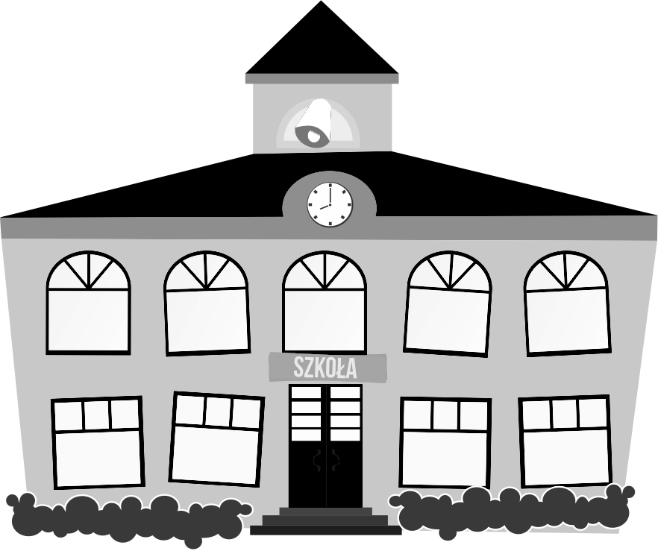
- On Mondays I get up at Thursday/ half past seven/ in the cinema.
- I go to school on foot/ on plane/ on 6 o’clock.
- My school is on/ in/ behind a supermarket.
- There are a park/ 2 cinemas/ turn left in my town.
- I have lunch/ to bed/ up at 1 o’clock.
- There is a park/ chips/ platform next to my house.

PART B Finish the sentences about you.

- On Mondays I get up at ..................................................................
- I go to school ...................................................................................
- My school is ....................................................................................
- There are ......................................................................... my town.
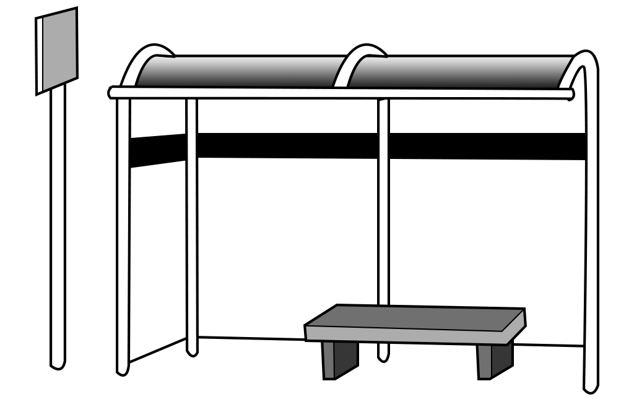
- I have lunch ..................................................................................
- There is ............................................................. next to my house.

