- There is ONE extra word in each sentence. Find it. Next, write the correct sentence.

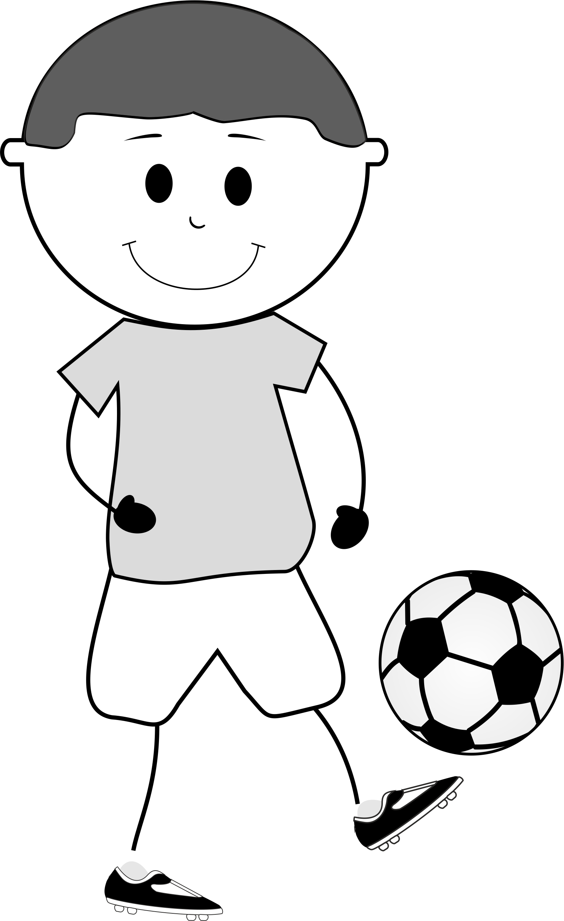
- I like playing football crisps.
...............................................................................................

- My sister cinema is reading a book.
...............................................................................................

- Why you don’t we play outside?
...............................................................................................

- I jellies get to school on foot.
...............................................................................................

- What do school you like doing?
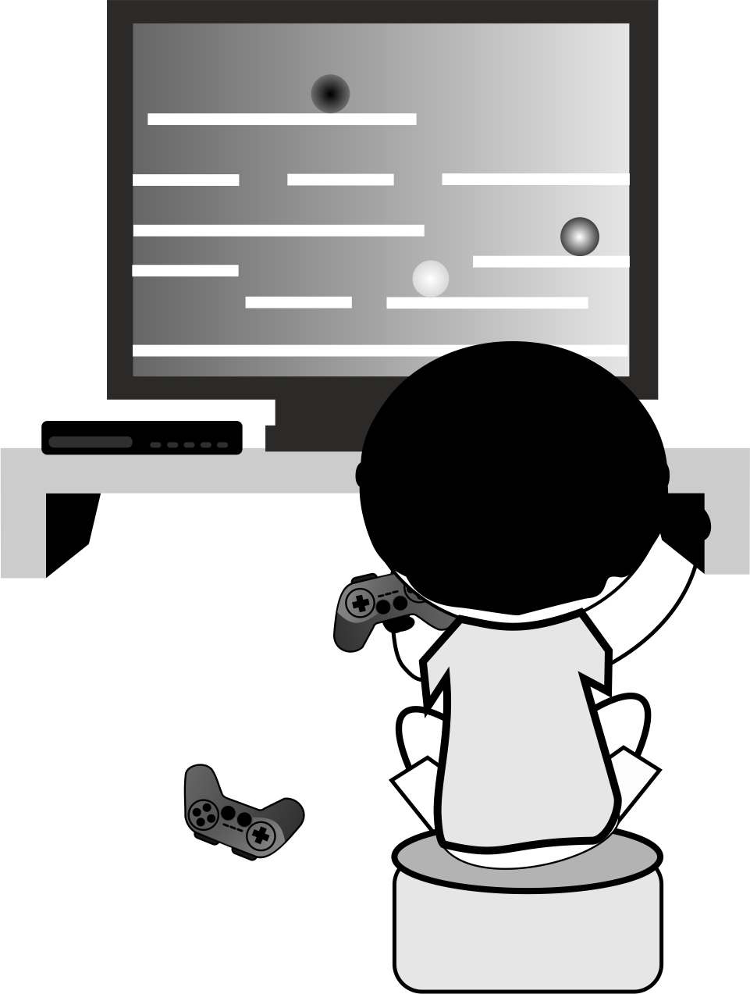
...........................................................................................

- What basketball time is my flight?
...........................................................................................

- Let’s play ticket computer games!
...........................................................................................

- I don’t boring like watching TV.
...........................................................................................

